**Causal Effects of Irrigation Proximity on Kebele-Level Canopy Greenness in Ethiopia’s Awash Basin:**

Evidence from Sentinel-2 NDVI and Multi-Period Difference-in-Differences

Yuhan Wang

CASA0010: MSc Urban Spatial Science Dissertation

Supervisor: Dr. Ollie Ballinger

[GitHub Repository](https://github.com/WYH-0324/CASA0010_Dissertation.git)

Word Count: 10,034

“This dissertation is submitted in part requirement for the MSc in the Centre for Advanced Spatial Analysis, Bartlett Faculty of the Built Environment, UCL”

22nd of August 2025

**Abstract**

Food insecurity in the Horn of Africa is shaped as much by water uncertainty as by land scarcity. Large irrigation schemes are often promoted as solutions, yet credible, fine-grained evidence on where irrigation improves crop conditions and which communities benefit remains limited. Conventional statistics are sporadic, expensive to collect, and aggregated at scales that obscure local heterogeneity.

This dissertation develops a reproducible, low-cost approach to measure kebele-level growing-season canopy greenness (NDVI) in Ethiopia’s Awash Basin using open satellite data and administrative boundaries. Rather than relying on field campaigns, the study assembles a transparent pipeline to produce decision-ready indicators of JJAS (June–September) crop condition and to compare Kesem-adjacent kebeles to suitable counterfactuals over 2018–2024. The period spans the multi-season 2020–2023 drought and partial recovery in 2024, allowing us to interpret any irrigation-linked greenness changes under pronounced weather stress.

Across a balanced panel with rainfall controls, multi-period Difference-in-Differences and event-study estimators yield an average treatment effect on NDVI that is statistically indistinguishable from zero, with a dip in 2022–2023 and rebound in 2024 consistent with basin-wide climate stress and recovery. Placebo and specification checks corroborate the null average while revealing spatial and temporal heterogeneity that is directly policy-relevant. The workflow—based on Sentinel-2 L2A (10–20 m), CHIRPS rainfall, VIIRS night-time lights, and ESA WorldCover cropland—is intended for routine use by local analysts, strengthening accountability and enabling targeted rehabilitation and complementary services where they are most needed.

**Declaration**

I, Yuhan Wang, hereby declare that this dissertation is all my own original work and that all sources have been acknowledged. It is 10,034 words in length.

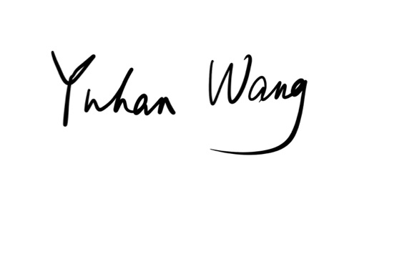

…………………...

Yuhan Wang

22nd of August 2025

**Acknowledgements**

I would like to express my deepest gratitude to my supervisor, Dr Ollie Ballinger, for his generous guidance, encouragement, and many insightful suggestions throughout the development of this dissertation. His expertise and high standards have shaped my thinking and substantially improved this work.

I am profoundly grateful to my parents, who consistently took care of my daily life during the entire dissertation-writing process. In the final phase of this work, I unfortunately developed a severe allergic reaction accompanied by a persistent fever. It was their meticulous care, unwavering support, and understanding that enabled me to remain focused on my research and successfully finalise this dissertation.

I also wish to thank all data providers and platforms that made open-source datasets available for this study. Their accessible and reliable resources laid a crucial foundation for the empirical analysis and validation presented here.

The past year has been one of the most important and remarkable of my life. Looking ahead, I will carry forward the rigour and integrity I have learnt at CASA into whatever comes next, and I am deeply grateful to everyone I met this year.

**CONTENTS**

List of Figures 7

List of Tables 8

List of Acronyms and Abbreviations 9

1 Introduction 10

2 Literature review 11

2.1 Kebele-scale evidence on irrigation outcomes is essential 11

2.2 Earth observation for vegetation condition: capabilities and limits 14

2.3 Causal identification: multi-period DiD and event studies 16

2.4 Evidence on irrigation impacts in Sub-Saharan Africa and in the Awash Basin 18

2.5 Spatial dependence and spillovers in irrigated landscapes 19

2.6 Drought context: interpreting irrigation under stress 19

2.7 Synthesis: what is known, what is not, and this study’s advance 20

2.8 EO–econometrics workflows for irrigation evaluation 20

2.9 NDVI, water stress, and agronomy: interpreting greenness under drought 21

2.10 Design choices that matter: AOI definition, masking, compositing, and valid-pixel accounting 22

2.11 Ethiopia and the Awash Basin: infrastructure, institutions, and operational 22

2.12 Spatial dependence, spillovers, and scale: what the econometrics implies for 23

2.13 Drought as identification context: reading dynamic effects and setting policy 24

3 Methodology 25

3.1 Study area, AOI rationale, and study period 25

3.2 Data Preprocessing 26

3.3 Identification Strategy and Econometric Specification 27

3.4 Spatial Models 29

3.5 Robustness and Diagnostics 29

3.6 Ethics, Reproducibility and Software 30

4. Results 31

4.1 Location analysis 31

4.2 Exposure, sample, and comparability 33

4.3 Rainfall and greenness context (maps) 36

4.4 Sample balance, overlap, and construct validity 44

4.5 Baseline Difference-in-Differences estimates 45

4.6 Event-study dynamics and drought context 47

4.7 Placebo and permutation tests 48

4.8 Robustness and specification sensitivity 49

4.9 Heterogeneity by exposure intensity and geography 50

4.10 Spatial dependence and spillovers 51

4.11 Visual triangulation from annual composites 52

4.12 Synthesis and implications 53

5. Discussion 54

5.1 Interpreting a small average effect under drought 54

5.2 Mechanisms consistent with the observed pattern 54

5.3 Positioning within the literature 55

5.4 How robust is the “small mean effect”? 55

5.5 Social and institutional dimensions: operations over enlargement 56

5.6 Policy implications: from expansion narratives to a rehabilitation agenda 56

5.7 Limitations reappraised 57

5.8 Directions for future research: from prototype to policy instrument 57

6. Conclusion 58

6.1 Main findings 58

6.2 Implications for policy and practice 58

6.3 Limitations and how they shape future work 59

6.4 Significance and generalisability 60

7. References 62

Appendix 65

Appendix A — Data & Methods 65

Appendix B — Diagnostics & Robustness 67

Appendix C — Reporting, Power & Governance 68

# List of Figures

Figure 2.1.1 Comparison of the capabilities of Landsat, 12

Figure 2.1.2. Sentinel-2 MSI spectral bands 13

Figure 2.2.1. Performance of vegetation indices 15

Figure 2.2.2. Comparison of satellite resolution 16

Figure 2.4. Sentinel-2 Level-1 processing chain from telemetry 19

Figure 3.1.1: Location of Ethiopia’s Awash Basin 25

Figure 4.A.1: Ethiopia context map (AOI, Kesem centre, 25 km buffer). 31

Figure 4.A.2: Treated vs control kebele mesh. 32

Figure 4.2a: Distribution of Treatment Intensity Across Kebeles 33

Figure 4.2b: Distribution of NDVI (Pre-Treatment) by Group. 34

Figure 4.2c : Baseline contrasts by treatment group (boxplots). 35

Figure 4.B.1: CHIRPS JJAS 2023 (mm). 36

Figure 4.B.2: CHIRPS JJAS 2024 (mm). 37

Figure 4.C.1: NDVI JJAS 2019 (10 m, season-max). 38

Figure 4.C.2: NDVI JJAS 2023. 39

Figure 4.C.3: NDVI JJAS 2024. 40

Figure 4.C.4: NDVI anomaly (2023 vs 2018–2019 baseline). 41

Figure 4.D.1: VIIRS annual mean 2024. 42

Figure 4.E.1: Kebele exposure share. 43

Figure 4.4.1 : Average NDVI by Group, 2018–2024 44

Figure 4.4.2: Correlation Matrix of Key Variables 45

Figure 4.5: Approximate MDE under clustering 46

Figure 4.6.1：Event Study: Treated × Year (relative to 2020; −1 omitted) 48

Figure 4.6.2：Dynamic Effects (Alternative plotting) 48

Figure 4.7: Distribution of Placebo ATT Estimates 49

Figure 4.8 : Funnel Plot / Specification Curve of ATT Across Variants 50

# List of Tables

Table 2.3. Key features of the Sentinel-2 mission 17

Table 3.2. Earth-observation and ancillary data 26

Table 3.3. Key parameters for treatment/control classification in GEE 28

Table 4.2: Baseline Contrasts and Overlap Diagnostics 34

Table 4.5：Baseline DiD (kebele & year FE; kebele-clustered SEs) 46

Table 4.6: Event-Study Coefficients and Joint Pre-trend Tests 47

Table 4.8: Robustness Summary (by clustering, coding, trimming, outcomes) 50

Table 4.9.1 : ATT by Exposure Threshold 51

Table 4.9.2 :Zone-Level Heterogeneity 51

Table 4.10 : Spatial Diagnostics (Moran’s I by year; p-values) 52

# List of Acronyms and Abbreviations

**AOI** Area of Interest

**ATT** Average Treatment Effect on the Treated

**AUC** Area Under the Curve

**CHIRPS** Climate Hazards Group InfraRed Precipitation with Station data

**DiD.** Difference-in-Differences

**ESA** European Space Agency

**EVI** Enhanced Vegetation Index

**EVI2** Two-band Enhanced Vegetation Index

**FAO** Food and Agriculture Organization (United Nations)

**GEE** Google Earth Engine

**GFSAD** Global Food Security-support Analysis Data

**GPS** Global Positioning System

**JJAS** June-September (monsoon season)

**L2A** Level-2A (Sentinel-2 surface reflectance)

**LISA** Local Indicators of Spatial Association

**MODIS** Moderate Resolution Imaging Spectroradiometer

**NDVI** Normalized Difference Vegetation Index

**O&M** Operations and Maintenance

**PNAS** Proceedings of the National Academy of Sciences

**SAR** Spatial Autoregressive Model

**SD** Standard Deviation

**SDM** Spatial Durbin Model

**SEM** Spatial Error Model

**VIIRS** Visible Infrared Imaging Radiometer Suite

**WLS** Weighted Least Squares

# 1 Introduction

Agricultural outcomes in Ethiopia’s Awash Basin are constrained by hydrological uncertainty: highly variable rainfall exposes farmers to recurrent shortfalls, motivating large-scale irrigation as a stabilisation instrument. Yet, despite decades of investment, decision-makers still lack credible, fine-grained evidence on whether specific schemes deliver measurable improvements where people live. Conventional statistics are delayed and aggregated; household surveys are episodic and costly. Meanwhile, open Earth observation now supports high-resolution monitoring of crop condition at scales relevant to planning (Burke and Lobell, 2017).

Context and scope. This study focuses on kebele-level growing-season canopy greenness (NDVI) rather than yields, using it as an agronomic proxy that is measurable at high spatial resolution and consistently across time with open Earth-observation products. The analysis is deliberately restricted to 2018–2024: harmonised Sentinel-2 L2A provides stable 10–20 m surface reflectance; ESA WorldCover v200 (class 40) offers a high-quality cropland baseline for aggregation; and the window spans the 2020–2023 multi-season drought followed by partial recovery in 2024, enabling interpretation under pronounced weather stress.

This dissertation addresses that gap for the Kesem scheme. Rather than asserting yield gains, it measures kebele-level growing-season canopy greenness (NDVI) as an agronomic proxy and asks whether greenness changes are associated with scheme proximity, controlling for weather using CHIRPS rainfall (Funk et al., 2015). Open satellite products—Sentinel-2 L2A (10–20 m), CHIRPS, VIIRS night-time lights, and ESA WorldCover—are paired with multi-period DiD and event-study estimators to move beyond descriptive maps toward cautious causal statements (Angrist and Pischke, 2009; Sun and Abraham, 2021; Callaway and Sant’Anna, 2021).

**Research questions.**

RQ1: Is proximity to the Kesem command area associated with changes in kebele-level JJAS NDVI over 2018–2024?

RQ2: Are effects state-dependent, strengthening in dry years in line with irrigation’s buffering role during the 2020–2023 drought?

RQ3: How heterogeneous are effects by exposure intensity and geography, and what does this imply for targeting rehabilitation rather than blanket expansion?

Scientifically, the study integrates 10–20 m EO with modern DiD/event-study to produce reproducible causal evidence at kebele scale. For policy, it yields decision-ready summaries and maps to target rehabilitation and complementary services where greenness gains remain persistently absent.

# 2 Literature review

## 2.1 Kebele-scale evidence on irrigation outcomes is essential

Ethiopia’s irrigation agenda is central to its water-for-growth strategy, yet systematic evidence at **decision-making scales** remains scarce. Country diagnostics (e.g., FAO AQUASTAT) document potential and expansion but also **information deficits** that impede benchmarking, routine monitoring and fair targeting of rehabilitation. Statistics often aggregate to **region or basin** levels, obscuring heterogeneity across **kebeles**—the administrative units where operations succeed or falter. For planning, frequent, spatially comparable, **reproducible** evidence at kebele scale is therefore essential to (i) detect under-performing pockets, (ii) prioritise maintenance and scheduling reforms, and (iii) evaluate whether command-area investments deliver outcomes beyond rhetoric.

Within the Awash system, technical and policy analyses have mapped infrastructure and institutional reforms, but they repeatedly call for **outcome metrics**—vegetation condition, seasonal stability, and resilience—beyond administrative reporting. This motivates an EO-driven approach that is both **transparent** and **repeatable**, using open products and standardised processing pipelines.

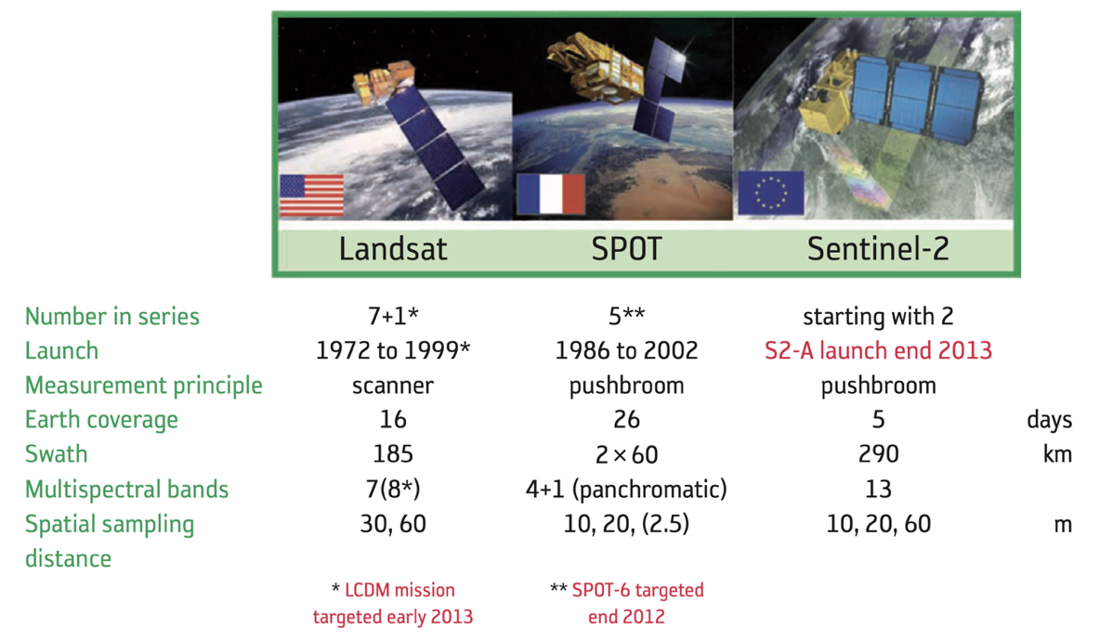

**Figure 2.1.1 Comparison of the capabilities of Landsat,**

SPOT and Sentinel-2.(Astrium GmbH, Germany)

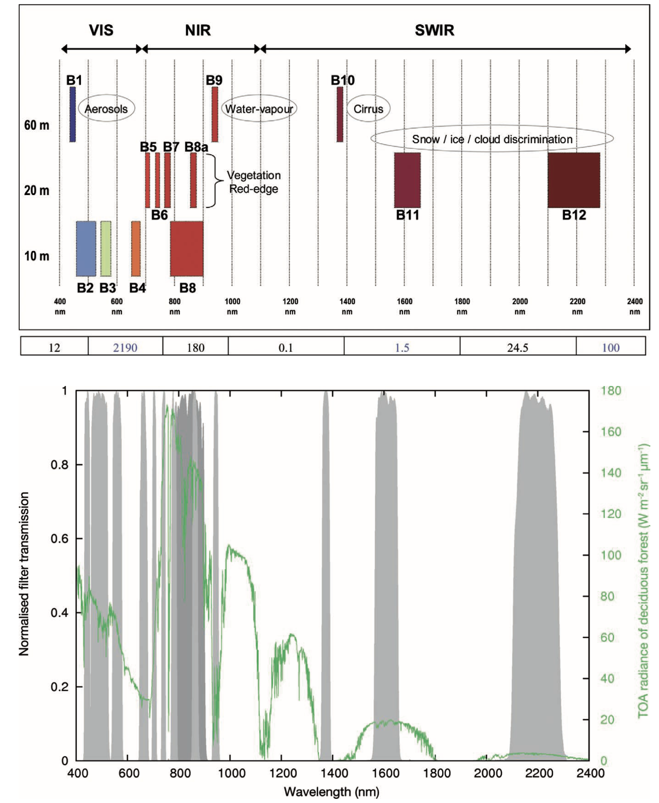

**Figure 2.1.2. Sentinel-2 MSI spectral bands**

**and spatial resolutions relevant to crop and irrigation monitoring (red-edge and SWIR bands highlighted). Source: ESA (2012), SP-1322/2, Fig. 3.5.**

## 2.2 Earth observation for vegetation condition: capabilities and limits

(1) Sensor capabilities and EO workflow

Sentinel-2 MSI provides 10–20 m optical bands, including red-edge channels, at high revisit frequency, enabling field- and kebele-scale monitoring of canopy status (Drusch et al., 2012). Standard indices such as NDVI capture contrast between near-infrared and red reflectance and are widely used as proxies for canopy greenness. In smallholder settings, high-resolution indices help explain yield variation and input response when combined with agronomic knowledge (Burke and Lobell, 2017). Because mixed pixels can bias averages, especially at field edges or in intercropped mosaics, analysts often confine computations to cropland masks; continental-scale classifiers on Google Earth Engine (e.g., WorldCover; GFSAD alternatives) enable this at 10–30 m scale (Xiong et al., 2017; ESA WorldCover Consortium, 2022).

Vegetation responds strongly to water availability. CHIRPS blends satellite and station data into 0.05° daily precipitation fields that are widely adopted in African agro-climatic analysis and validated against gauges (Funk et al., 2015). Pairing NDVI with CHIRPS helps control for inter-annual shocks and improves interpretation of greenness changes near canals. VIIRS night-time lights provide contextual proxies for settlement and economic activity (Elvidge et al., 2017); while not field outcomes, they can flag urban/industrial contamination in cropland masks or detect secular expansion that might correlate with water delivery.

(2) What NDVI can and cannot say

NDVI is attractive because it is simple, transparent, and available at high spatial and temporal resolution. But it is not yield. At high biomass the index can saturate, compressing variation among dense canopies; intercropping and fallow-crop mosaics can mix spectra; harvest timing and crop choice can decouple peak greenness from harvested output. In rain-fed settings, NDVI often tracks soil moisture and evapotranspiration; irrigation can also shift phenology (earlier green-up, delayed senescence) without raising seasonal peaks. These caveats do not invalidate NDVI; rather they discipline interpretation: effects should be framed as changes in growing-season canopy greenness. Empirically, plot-scale studies in East Africa show that high-resolution greenness metrics explain substantial variation in smallholder yields (Burke and Lobell, 2017), especially when analysed over cropland masks and paired with independent rainfall controls. The present study follows this logic and augments mean NDVI with percentile and duration metrics in robustness (e.g., p95, AUC).

(3) Alternatives and complements

Where saturation is a concern, EVI/EVI2 mitigate non-linearities through blue-band normalisation; short-wave infrared composites improve sensitivity to plant water stress; and thermal-based ET proxies (SEBAL/METRIC families) offer biophysical interpretability at higher modelling cost. Because different metrics capture peaks (p95), levels (mean), and duration (AUC), triangulation strengthens inference. In practice, a pragmatic monitoring stack for public agencies prioritises low-cost indices (NDVI mean/p95/AUC) with occasional deep-dives when anomalies are persistent. baseline.

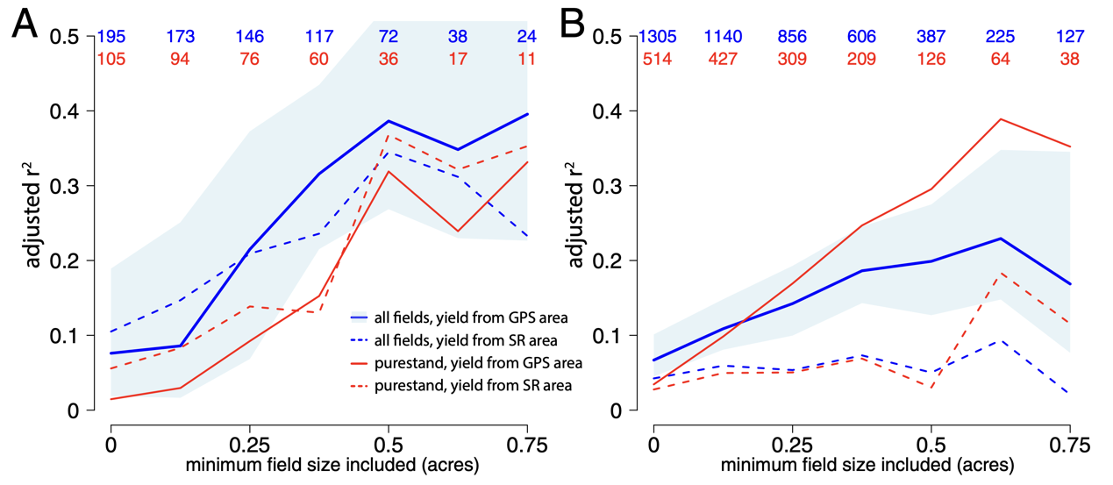

**Figure 2.2.1. Performance of vegetation indices**

**(GCVI and NDVI) in predicting GPS-corrected farmer self-reported yields, reproduced from Burke & Lobell (2017), PNAS.**

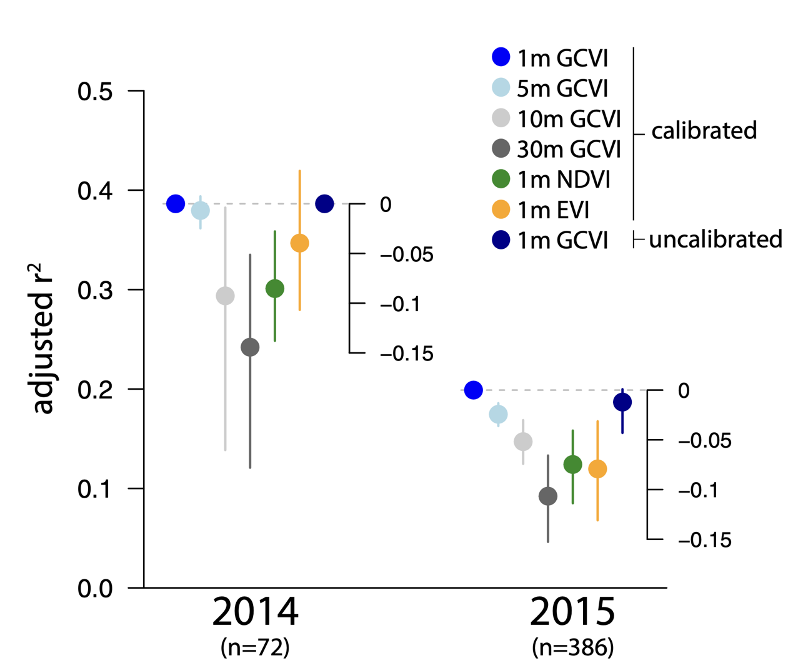

**Figure 2.2.2. Comparison of satellite resolution**

(1m, 5m, 10m, 30m) in predicting GPS-corrected farmer self-reported yields, reproduced from Burke & Lobell (2017), PNAS.

## 2.3 Causal identification: multi-period DiD and event studies

(1) The DiD workhorse and its pitfalls

In non-experimental settings, Difference-in-Differences (DiD) estimates average treatment effects under parallel trends (Angrist and Pischke, 2009). Conventional two-way fixed effects (TWFE) estimators are convenient but, under staggered or heterogeneous treatment, combine many 2×2 contrasts with potentially negative or inappropriate weights, producing biased estimates (Goodman-Bacon, 2021). In irrigation contexts, where exposure intensity varies continuously and operations evolve, these pathologies are salient.

(2) Modern solutions and practice

Two families of solutions now anchor best practice. First, Callaway and Sant’Anna (2021) propose group-time average treatment effects (ATTs) with transparent aggregation, accommodating heterogeneous adoption and allowing covariate-adjusted parallel trends. Second, Sun and Abraham (2021) provide consistent event-study coefficients with heterogeneous effects, enabling visual pre-trend checks and dynamic treatment profiles. Empirical applications increasingly pair these estimators with randomisation-inference placebos, specification curves, and robust error structures (e.g., Conley spatial HAC) to guard against fragile inferences. Because Kesem exposure is time-invariant in our main window, TWFE pathologies are attenuated; nevertheless, the study adopts modern estimators, plots event-time dynamics, and reports placebos to discipline claims.

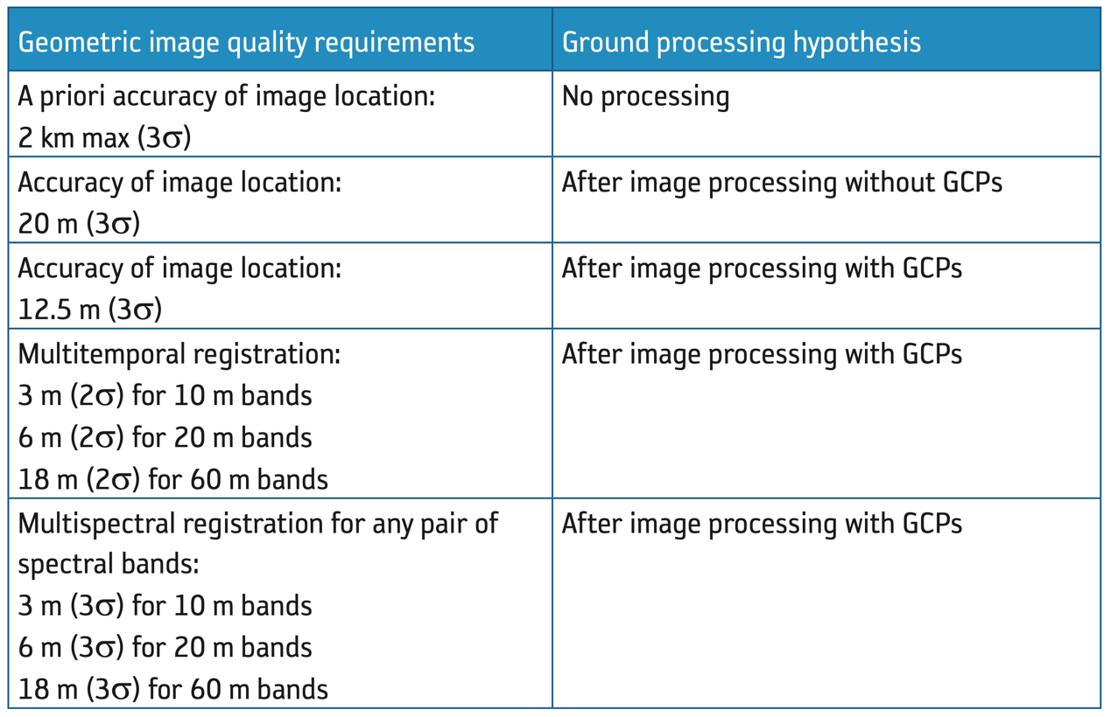

Table 2.3. Key features of the Sentinel-2 mission

**(orbit, revisit, swath, coverage) underpinning village-level panel construction in the Awash Basin. Source: ESA (2012), SP-1322/2, Table 3.1.**

## 2.4 Evidence on irrigation impacts in Sub-Saharan Africa and in the Awash Basin

Findings across Sub-Saharan Africa are mixed. Remote-sensing studies have Findings across the region are mixed. Remote-sensing studies document greenness gains near irrigated plots, but many rely on coarse sensors (e.g., MODIS) and lack counterfactuals. Survey-based evaluations identify heterogeneity driven by conveyance reliability, scheduling, market access, and extension. In Ethiopia, sector diagnostics note rapid scheme proliferation but limited outcome monitoring and uneven performance. Within the Upper–Middle Awash, work around Koka Lake has mapped spatio-temporal patterns of smallholder irrigated agriculture using Sentinel-2 and GEOBIA, revealing strong seasonal signatures and rapid land-use transitions (Vogels et al., 2019). Yet most analyses stop at descriptive trends; kebele-scale causal designs remain rare, in part because consistent administrative boundaries, crop masks, and multi-year cloud-free composites became tractable only in the Sentinel-2 era.

Hydrologic and sediment studies of the Kesem watershed emphasise runoff generation, sediment yield, and dam performance (Abebe and Gebremariam, 2019), offering geographic anchors and engineering context but not micro-scale agronomic outcomes. This dissertation extends the portfolio by integrating 10–20 m greenness measures with modern DiD/event-study to produce kebele-scale causal evidence in the very basin where policy demand is high.

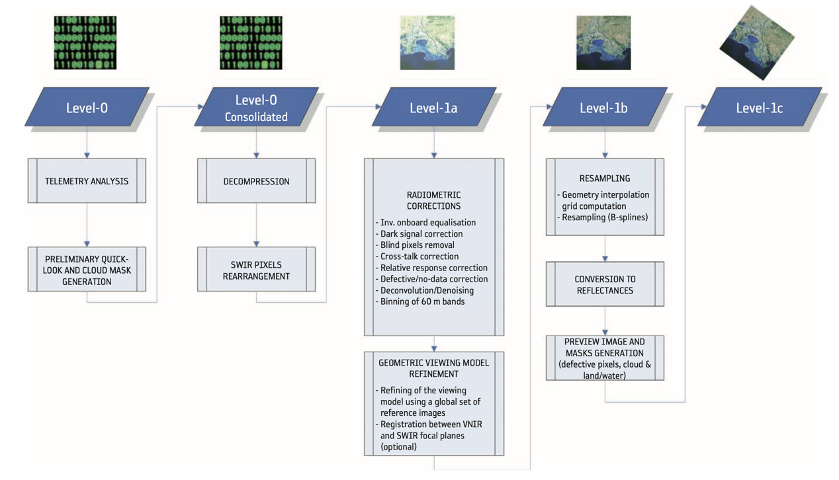

**Figure 2.4. Sentinel-2 Level-1 processing chain from telemetry**

to orthorectified TOA reflectance (L1C) with cloud and land/water masks. Source: ESA (2012), SP-1322/2, Fig. 7.1.

## 2.5 Spatial dependence and spillovers in irrigated landscapes

Irrigation effects are not strictly local. Canal networks, seepage, groundwater mounding, and learning spillovers can transmit benefits—or costs such as salinity—across administrative boundaries. Spatial econometrics formalises the consequences of such dependence for estimation and interpretation. Anselin (1988) introduced the spatial lag and error frameworks; Elhorst (2014) systematised inference for static and spatial panels, including the Spatial Durbin Model (SDM) that decomposes direct and indirect (spillover) effects. In data-sparse irrigation settings, analysts often rely on contiguity or distance-band weights as first-best proxies for hydraulic neighbourhoods. Embedding spatial lags within a panel DiD helps assess whether benefits extend beyond treated kebeles, a prerequisite for landscape-scale cost–benefit appraisals.

## 2.6 Drought context: interpreting irrigation under stress

The 2020–2023 period in the Greater Horn of Africa is widely characterised as an exceptional multi-season drought driven by consecutive poor rains and amplified by anthropogenic warming (World Weather Attribution, 2023), with severe food insecurity impacts (ICPAC/IGAD, 2023; WHO, 2023). In such conditions, irrigation may function primarily as a buffer, sustaining canopy greenness rather than raising peaks—particularly where conveyance is intermittent or allocation is rationed. Event-time profiles that dip in 2022–2023 and rebound in 2024 are therefore consistent with a buffering narrative, even if the average DiD effect is small. Designing monitoring systems that explicitly report dry-year performance is thus essential for accountability.

## 2.7 Synthesis: what is known, what is not, and this study’s advance

Knowns. High-resolution EO (Sentinel-2), robust rainfall products (CHIRPS), and continental cropland masks (WorldCover) make kebele-scale monitoring feasible. Modern DiD/event-study estimators improve causal identification under heterogeneity. Spatial panels enable spillover assessment.

Unknowns. In the Awash Basin, there remains little kebele-level causal evidence on how large-scale schemes translate into measurable greenness changes, particularly under drought. The spatial reach of any benefits is poorly characterised without canonical canal networks; the sensitivity of conclusions to exposure thresholds, outcome definitions, and error structures also warrants systematic assessment.

Advance. The present study integrates Sentinel-2 NDVI, CHIRPS rainfall, WorldCover cropland, and kebele boundaries in a transparent, reproducible pipeline; applies multi-period DiD and event-studies consistent with current econometric guidance; probes spillovers with spatial diagnostics; and interprets findings within the 2020–2023 drought / 2024 recovery context. The goal is not to settle yield debates, but to build a monitoring-ready template that public agencies can sustain—one that converts open EO into decision-relevant, auditable evidence at the scale where rehabilitation and scheduling decisions are actually made.

## 2.8 EO–econometrics workflows for irrigation evaluation

A recurring challenge in EO-based irrigation studies is the translation from descriptive maps to causal inference. Map products—multi-year greenness composites, phenology curves, land-cover change—are decision-relevant but not sufficient for programme attribution. Contemporary practice therefore layers (i) a transparent exposure rule (e.g., proximity to a command centre or canal network), (ii) administrative aggregation to the decision unit (here, kebele), (iii) shock controls (rainfall), and (iv) panel estimators aligned with modern DiD guidance (Angrist and Pischke, 2009; Sun and Abraham, 2021; Callaway and Sant’Anna, 2021). The present dissertation follows that architecture deliberately: an AOI tailored to the Kesem footprint, a buffer-based treatment indicator varied in sensitivity (20/25/30 km; 1–10% overlap; 3–10 km exclusion), cropland-masked Sentinel-2 JJAS NDVI, and group-time/event-study estimators, complemented by randomisation-inference placebos and specification curves (Goodman-Bacon, 2021). This stacking of measurement, design, and diagnostics reflects the field’s shift from one-off maps to monitoring systems that support accountability.

Acorollary is the need for construct clarity: the outcome is kebele-level growing-season canopy greenness, not yields or income. That distinction—already stressed in §2.2—prevents indicator slippage and aligns with public-sector needs to identify under-performing locales for O&M, independent of market volatility.

## 2.9 NDVI, water stress, and agronomy: interpreting greenness under drought

NDVI conflates biomass and water status signals; under water stress, reductions in leaf area and stomatal conductance both depress canopy greenness. In rain-fed mosaics, NDVI often tracks soil moisture and ET; irrigation primarily affects greenness by sustaining canopy function when rainfall falters. This implies state dependence: NDVI treatment effects are expected to be largest in dry years and smaller in wet years—precisely the pattern probed by event-time profiles in this study. Plot-level evidence from East African smallholders demonstrates that high-resolution greenness indices capture meaningful agronomic variation (Burke and Lobell, 2017), but the magnitude of detectable differences depends on (i) baseline canopy density (NDVI saturation risk), (ii) cropping calendars, and (iii) intra-seasonal timing of water deliveries. Seasonal-maximum compositing (qualityMosaic[‘NDVI’]) privileges peaks; duration-sensitive metrics (AUC) often reveal stabilisation effects that peak-only measures understate. This dissertation therefore triangulates mean NDVI with percentile (p95) and AUC in robustness (§3.5), consistent with agronomic expectations.

2.10 Design choices that matter: AOI definition, masking, compositing, and valid-pixel accounting

Causal identification is only as strong as the measurement scaffolding. Four design choices are pivotal and widely discussed in EO-for-agriculture practice:

1. AOI definition. The AOI should enclose the scheme, plausible spillover radii, and a ring of controls that share agro-ecological context; it should also align with Sentinel-2 tiling and CHIRPS grids to avoid seam artefacts (Drusch et al., 2012; Funk et al., 2015). The present rectangle [39.5°, 8.6°, 41.2°, 10.9°] was chosen exactly for these reasons and to enable computational tractability.

2. Cropland masking. Confining analysis to WorldCover v200 class 40 reduces mixed-pixel bias, strengthening correspondence between greenness changes and field conditions (ESA WorldCover Consortium, 2022; Xiong et al., 2017).

3. Compositing. JJAS qualityMosaic maximises cloud robustness and cross-year comparability while emphasising peak greenness; reporting AUC/p95 complements this peak focus.

4. Valid-pixel accounting. Tracking cropland-valid fractions at kebele×year prevents artefacts from thin samples in cloudy seasons; excluding observations below a coverage threshold ensures that noisy years do not spuriously drive estimates.

2.11 Ethiopia and the Awash Basin: infrastructure, institutions, and operationalheterogeneity

Large schemes in Ethiopia operate within complex hydro-institutional settings. Conveyance losses, sedimentation, and rotational scheduling create intra-command heterogeneity that can swamp scheme-average narratives. Hydrologic studies of Kesem’s catchment (e.g., runoff and sediment yield modelling) provide engineering context and geographic anchors (Abebe and Gebremariam, 2019), while sector diagnostics highlight expansion amid limited outcome monitoring and uneven performance (FAO, 2016). In the Upper–Middle Awash, remote-sensing analyses (e.g., around Koka Lake) show intense seasonal signatures and rapid land-use transitions, underlining the need for high-resolution sensors (Sentinel-2) and administrative aggregation to distinguish command-area effects from basin-wide cycles (Vogels et al., 2019).

Institutionally, water-user associations, fee regimes, and O&M budgets determine delivery reliability as much as hydraulic design. This suggests that spatial variance in NDVI within command areas can be policy-diagnostic: flat or negative greenness responses may reflect gates, laterals, or rotation rules, not just climate. Embedding EO signals in kebele-scale scorecards taps into this governance frontier—turning satellite time series into auditable service metrics.

2.12 Spatial dependence, spillovers, and scale: what the econometrics implies forirrigation

Irrigation effects rarely stop at polygon boundaries. Seepage from lined/unlined canals, shallow groundwater mounding, and learning spillovers (imitation, input sharing) transmit impacts across administrative borders; conversely, salinity or waterlogging can impose negative externalities. Ignoring these processes biases both effect sizes and welfare accounting. Spatial econometrics formalises dependence: Spatial Lag (SAR) and Spatial Error (SEM) models capture interactions in outcomes and unobservables; the Spatial Durbin Model (SDM) decomposes direct and indirect effects and is particularly informative for landscape-scale policy (Anselin, 1988; Elhorst, 2014).

Without a canonical canal graph, analysts adopt contiguity or distance-band weights as first-best proxies, interpreting indirect effects as lower bounds on hydraulic/social spillovers—an approach this dissertation mirrors. Importantly, the scale of aggregation matters: kebele-means can dilute micro-canal effects; however, they align precisely with budgeting and accountability units, making them the right scale for public reporting, with micro-studies as complements rather than substitutes.

2.13 Drought as identification context: reading dynamic effects and setting policytargets

The 2020–2023 drought across the Greater Horn provides a stress test for irrigation’s social value. Regional assessments document the severity and food-security consequences (ICPAC/IGAD, 2023; WHO, 2023), while attribution science highlights anthropogenic contributions to drought intensity (World Weather Attribution, 2023). Under such conditions, irrigation is expected to act as a buffer, with effects materialising as shallower dips or faster rebounds rather than uniform uplifts. This makes event-study plots—with pre-trend checks and post-shock dynamics—central to interpretation (Sun and Abraham, 2021).

Policy targets should mirror this state dependence: dry-year scorecards that condition on rainfall anomalies, linking O&M budgets to reliability under stress, arguably yield higher social returns than expansion metrics focused on acreage. The present study’s emphasis on dip-and-recovery dynamics and small mean effects should thus be read not as a failure to detect benefits, but as evidence that operational reliability—rather than footprint—drives welfare in drought-prone basins.

Pulling these strands together, the frontier for EO-based irrigation evaluation is not a single “better index,” but a workable system: (i) high-resolution EO (Sentinel-2) aggregated to administrative units over cropland masks; (ii) modern panel estimators with explicit dynamic diagnostics and placebos; (iii) spatial tools that quantify spillovers; and (iv) policy interfaces—kebele-level scorecards, dry-year targets, and O&M triggers. Within this framework, the Awash/Kesem case is not just a local study; it is a template for routine, auditable irrigation monitoring in low-data environments, consistent with the literature’s trajectory.

# 3 Methodology

## 3.1 Study area, AOI rationale, and study period

The Awash is an endorheic basin rising near Addis Ababa and terminating at Lake Abbe on the Djibouti border, commonly divided into upper, middle, lower reaches. The Kesem (Kessem) scheme lies in the middle-lower Awash. Hydrologic studies locate the dam area around 9°08′45″ N, 39°55′31″ E, with watershed bounds approximately 8°50′–9°20′ N, 39°00′–40°00′ E (Abebe and Gebremariam, 2019). For reproducibility, the AOI is a fixed rectangle [39.5°, 8.6°, 41.2°, 10.9°] that encloses the command area and surrounding kebeles required to define treated and comparable control units.

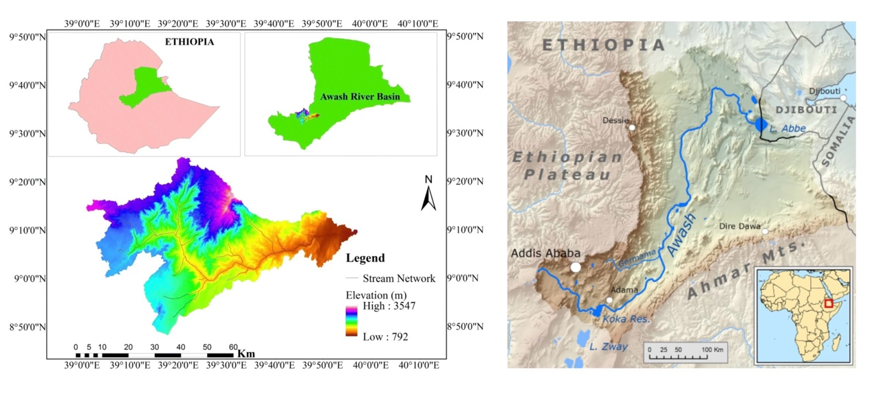

**Figure 3.1.1: Location of Ethiopia’s Awash Basin**

**AOI rationale.**

1. Coverage & identification: the AOI contains the scheme, a 25 km buffer for treatment definition, and an outer ring to draw 5 km-screened controls, enabling transparent counterfactuals;
2. Remote-sensing interoperability: it aligns with Sentinel-2 tiling and 0.05° CHIRPS grids, reducing seam artefacts and supporting consistent JJAS aggregation (Drusch et al., 2012; Funk et al., 2015);
3. Ecological and socio-agronomic coherence: focusing on middle-lower Awash limits elevation/urban heterogeneity and bolsters the plausibility of parallel trends;
4. Computational tractability: supports annual 10–20 m compositing and multi-year panel estimation;
5. Reproducibility: coordinate-explicit bounds allow independent re-execution and sensitivity checks.

Study period (2018–2024). We retain 2018–2024 as the primary window because harmonised Sentinel-2 L2A products and cloud screening are most stable from 2018 onwards; WorldCover v200 provides a high-quality 2021 cropland baseline for pixel-to-kebele aggregation; and the window spans the 2020–2023 drought with partial recovery in 2024, allowing us to benchmark irrigation-linked greenness under strong exogenous stress. The estimands therefore pertain to post-2018 marginal changes in kebele-level canopy greenness rather than long-run scheme construction effects.

Exogenous climate context. Regional assessments characterise 2020–2023 as an exceptional multi-year drought in the Greater Horn of Africa. If water deliveries were intermittent or constrained, the net effect on peak-season greenness could be modest even near canals—an interpretation later tested against the event-study profile.

## 3.2 Data Preprocessing

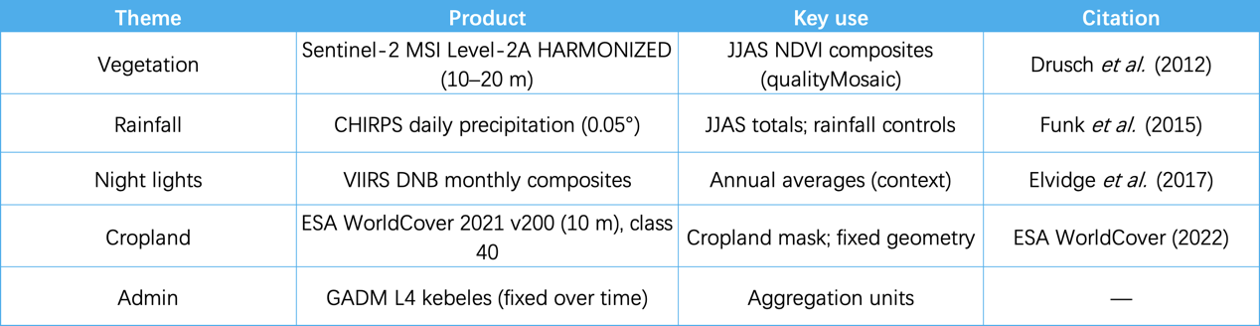

Table 3.2. Earth-observation and ancillary data

**Pre-processing.**

(1) Mask & units: Restrict all pixels to AOI∩cropland; aggregate to kebele×year panels using fixed pre-intervention boundaries.

(2) Cloud/shadow screening: Use S2 SCL to remove cloud, shadow, cirrus and saturation; compute NDVI = (B8−B4)/(B8+B4); generate JJAS qualityMosaic(‘NDVI’) to secure at least one cloud-free peak per pixel (Drusch et al., 2012).

(3) Outcomes: Primary—JJAS NDVI (kebele mean). Ancillary—JJAS rainfall (CHIRPS), VIIRS annual mean. Robustness outcomes include NDVI AUC, NDVI p95/max, EVI/EVI2 and simple phenology metrics (Burke and Lobell, 2017).

(4) Aggregation & QC: Reduce to kebele means at 60 m analysis scale; record valid-pixel shares; empty reductions are missing (NaN). Construct optional NDVI anomalies against 2018–2019 baselines.

## 3.3 Identification Strategy and Econometric Specification

Mechanism sketch and identification intuition. Proximity to the Kesem command area is expected to affect canopy greenness primarily through reliability of water deliveries rather than a uniform increase in seasonal maxima. Under drought stress, reliable irrigation should attenuate dips and enable faster rebounds, whereas in average years mean differences may be negligible. This state dependence motivates our use of event-time diagnostics and rainfall-interaction checks. The directed acyclic graph (DAG) below encodes the maintained assumptions guiding identification: rainfall shocks affect both irrigation reliability and vegetation greenness; proximity increases the probability of receiving deliveries; and we adjust for time-invariant kebele features and common year shocks via two-way fixed effects.

**Treatment & control (kebele).**

Treated: kebeles with ≥5% areal overlap with a 25 km buffer around the Kesem command area (Abebe and Gebremariam, 2019).

Control: non-treated kebeles within AOI, excluding those within 5 km of treated kebeles to mitigate spillover/contamination.

Assignments are time-invariant (pre-intervention geometry). Robustness varies thresholds: buffer 20/30 km; overlap 1%/10%; exclusion 3/10 km.

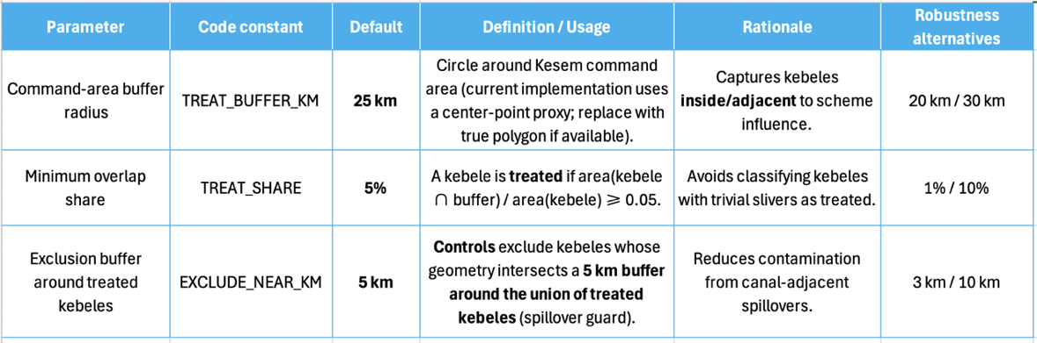

Table 3.3. Key parameters for treatment/control classification in GEE

**(Kesem scheme).**

Note: Control kebeles exclude those intersecting a 5 km buffer around the union of treated kebeles to reduce spillovers. Robustness explores 20/30 km buffer, 1%/10% overlap, and 3/10 km exclusion.

**Baseline DiD.**

Let $y_{it}$ denote kebele-mean JJAS NDVI; $T_{i}$ an indicator for treated; $P_{t}$ a post-2020 indicator; $X_{it}$ include JJAS rainfall and optional terrain/VIIRS controls. Estimate:

$$y_{it}=α_{i}+λ_{t}+β\left(T_{i}×P_{t}\right)+γX_{it}+ε_{it}$$

with kebele ($α_{i}$) and year ($λ_{t}$) fixed effects; kebele-clustered standard errors. Conley (spatial HAC) and two-way clustering (e.g., kebele×cohort) appear in robustness (Angrist and Pischke, 2009).

A simple DAG clarifies assumptions: irrigation proximity → (water availability, scheduling reliability) → canopy greenness (NDVI); rainfall shocks → greenness; terrain affects both cropland patterns and water delivery costs. Conditioning on kebele fixed effects absorbs time-invariant terrain/culture; year fixed effects absorb basin-wide shocks; CHIRPS controls residual within-year rainfall heterogeneity. Threats include time-varying inputs (fertilizer, extension) correlated with proximity. We mitigate these through night-lights controls (coarse economic activity proxy) and robustness to sub-samples that exclude industrial/built pixels.

**Event study.**

Estimate

$$y_{it}=α_{i}+λ_{t}+\sum_{k≠-1}{δ_{k}D_{it}^{k}}+γX_{it}+ε_{it}$$

where $D_{it}^{k}$ marks years relative to first post period; $k=-1$ omitted (Sun and Abraham, 2021).

All models are estimated with heteroskedasticity-robust standard errors clustered at kebele level. We report sensitivity to clustering at woreda and zone, and compute Conley (spatial HAC) errors with a 25–50 km cutoff to account for spatial correlation. Coefficients are presented with 95% confidence intervals; p-values are reported but not over-interpreted given multiple testing and finite-sample correlation. For the specification curve, we implement a consistent set of model toggles (clustering level; exposure coding; trimming; outcome definition), plot ATTs with inverse-variance weights, and annotate the median specification. Randomisation inference draws 1,000 permutations of treatment labels within AOI and recomputes the ATT to form an empirical null.

**Staggered adoption (if any).**

Report group-time ATTs per Callaway and Sant’Anna (2021) to avoid TWFE weight pathologies (Goodman-Bacon, 2021).

## 3.4 Spatial Models

Step 1 (diagnostic)—Moran’s I on DiD residuals using queen contiguity or distance bands.

Step 2 (spillover estimation)—panel SLX or Spatial Durbin (SDM):

$$y_{it}=α_{i}+λ_{t}+β\left(T_{i}×P_{t}\right)+θW\left(T_{i}×P_{t}\right)+ρWy_{it}+ΓWX_{it}+γX_{it}+u_{it}$$

reporting direct and indirect effects (Anselin, 1988; Elhorst, 2014).

## 3.5 Robustness and Diagnostics

Implemented a multi-pronged robustness program:

（1）Parameter sensitivity: buffer 25→20/30 km, overlap 5%→1%/10%, exclusion 5→3/10 km.

（2）Outcomes: replace NDVI mean with AUC/p95/max, EVI/EVI2; re-estimate.

（3）Weather interactions: include rainfall × treatment (and dry-year dummies).

（4）Sample restrictions: drop high VIIRS pixels or low valid-pixel shares.

（5）Placebos: false treatment years; spatially shifted buffers.

（6）Pre-trends: joint tests on k<0 coefficients in event study.

（7）Error structure: kebele-clustered; woreda/zone clustering; Conley spatial HAC.

（8）Optional matching: entropy balancing/propensity score before DiD.

## 3.6 Ethics, Reproducibility and Software

Open, aggregate geospatial data only; no PII; compliant with UCL ethics. All steps are scripted end-to-end. GEE for pre-processing and mapping; Dockerised Python (pandas, statsmodels, linearmodels, PySAL) for econometrics; fixed seeds; exported artefacts with checksums; dataset IDs and package versions recorded in appendix; public code repository linked.

# 4. Results

## 4.1 Location analysis

Map set A — Study footprint and treatment definition

A1. Ethiopia context map (AOI, Kesem centre, 25 km buffer).

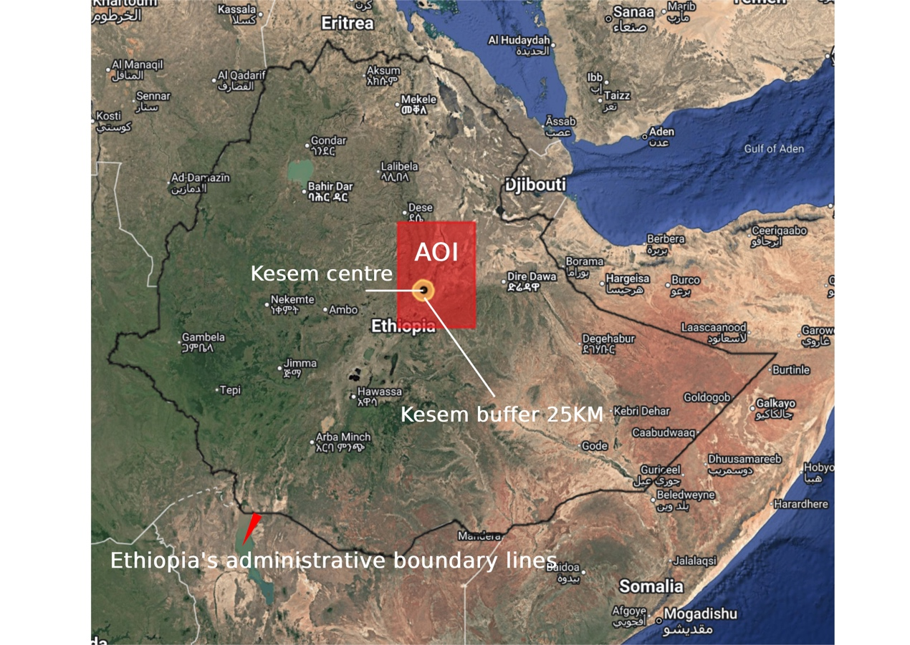

**Figure 4.A.1: Ethiopia context map (AOI, Kesem centre, 25 km buffer).**

The Area of Interest (AOI) spans the Upper–Middle Awash (39.5–41.2°E; 8.6–10.9°N). The Kesem scheme reference point and a 25 km buffer define the exposure neighbourhood used for the kebele-level treatment rule.

The AOI fixes a common spatial frame for all Earth-observation summaries and kebele assignment, large enough to incorporate a ring of comparable non-exposed kebeles (controls) while avoiding cross-basin seams. The 25 km radius was chosen ex-ante to bracket plausible canal-network and groundwater influence zones; sensitivity to alternative radii is reported in robustness checks.

A2. Treated vs control kebele mesh.

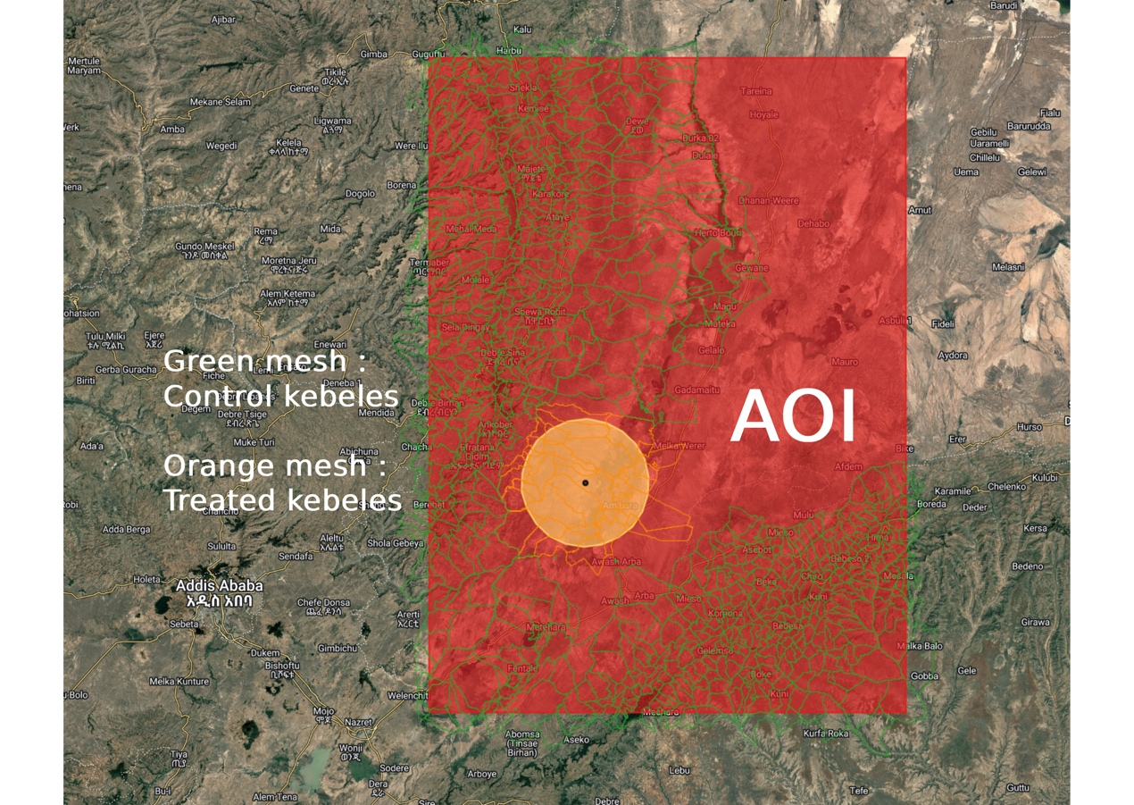

**Figure 4.A.2: Treated vs control kebele mesh.**

Figure 4.A.2. Kebele polygons intersecting the 25 km buffer by ≥5% of area are labelled “treated” (orange mesh). Kebeles outside the buffer and >5 km from the treated union are “controls” (green mesh). The rule yields a compact treated cluster centred on the Kesem command, with controls distributed across similar agro-ecological settings in the AOI.

Two identification points follow:

1. treatment is geographically coherent (consistent with canal layouts)
2. the control ring excludes immediate neighbors where seepage/learning spillovers are most likely.

## 4.2 Exposure, sample, and comparability

We construct a balanced kebele×year panel for 2018–2024 within the AOI. “Treated” kebeles have ≥5% areal overlap with the Kesem 25-km buffer; “controls” lie outside a 5-km exclusion band around the treated union. These thresholds match the GEE parameterization and are varied later (buffer 20/30 km; overlap 1%/10%; exclusion 3/10 km).

**Distribution of treatment intensity.** Exposure is highly right-skewed: most kebeles have near-zero overlap, with a short right tail (Fig. 4.2a). The exposure choropleth (Fig. 4.E.1) shows sharp spatial decay beyond the first one–two rings around Kesem, supporting the ≥5% threshold and the 5-km exclusion used to screen potential spillovers.

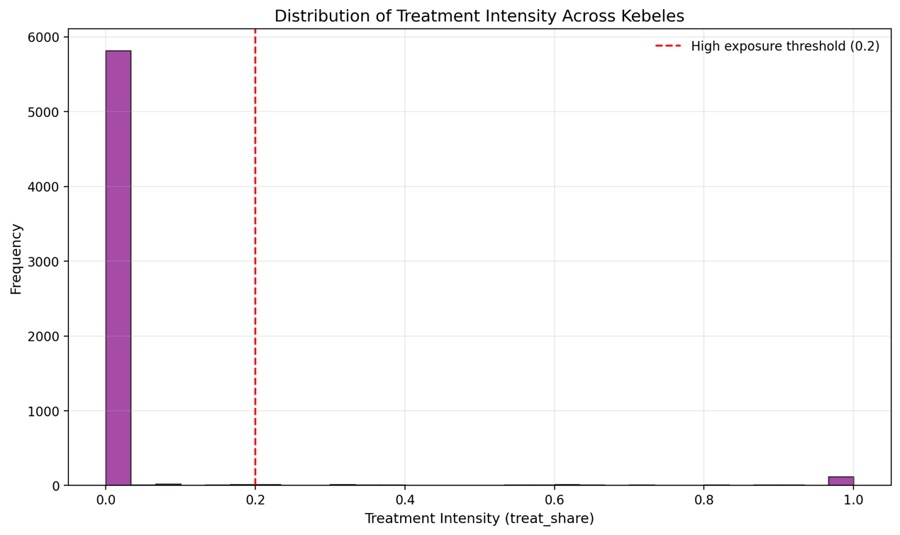

**Figure 4.2a: Distribution of Treatment Intensity Across Kebeles**

**Baseline balance.** Pre-period descriptive contrasts reveal comparable JJAS NDVI means and overlapping distributions across groups (Fig. 4.2b). Treated kebeles are modestly lower and flatter in topography on average; because these differences are time-invariant, kebele fixed effects absorb them. At basin scale, rainfall co-moves across kebeles; we therefore include year fixed effects and CHIRPS JJAS rainfall as time-varying controls to sharpen identification. A compact balance table (elevation, slope, pre-period NDVI, JJAS rainfall) indicates acceptable overlap for DiD; standardized mean differences for pre-period NDVI and rainfall lie within ±0.1 (Table 4.2). Correlations among key variables are moderate and do not suggest problematic collinearity (correlation matrix, appendix).

Role of VIIRS. Annual VIIRS night-lights are used diagnostically to flag potential urban/industrial confounding and to contextualize kebele-level economic activity; VIIRS is not an outcome of interest in this study but informs specification checks.

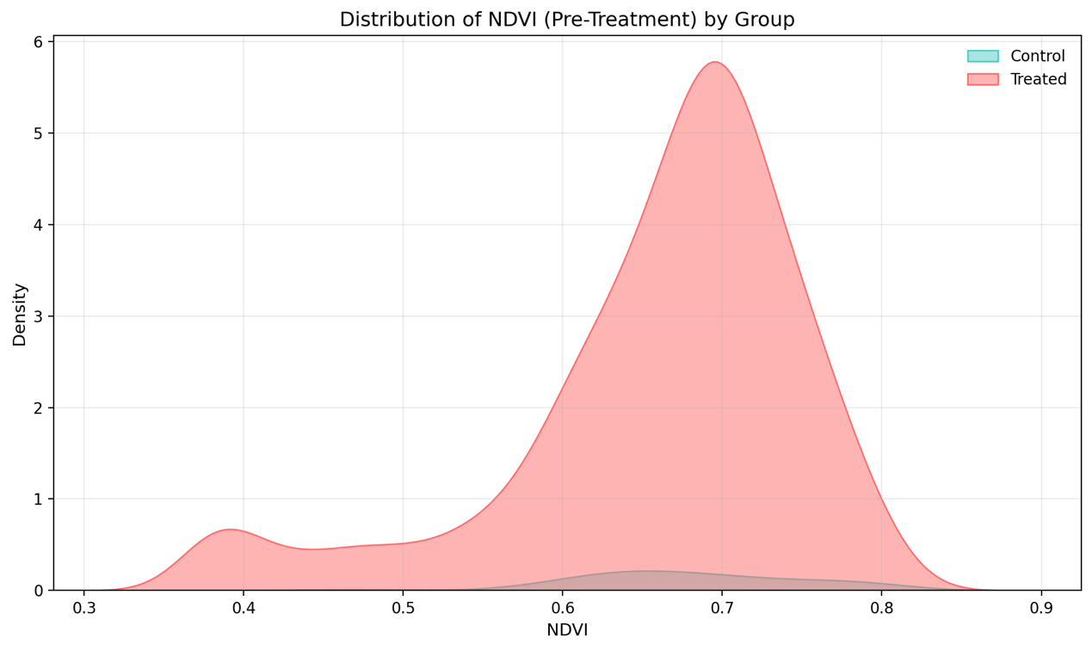

**Figure 4.2b: Distribution of NDVI (Pre-Treatment) by Group.**

Implication for identification. The joint evidence—tight treated cluster, control ring at safe distances, right-skewed exposure, and pre-period balance—makes a within-kebele design with modern DiD estimators the appropriate workhorse.

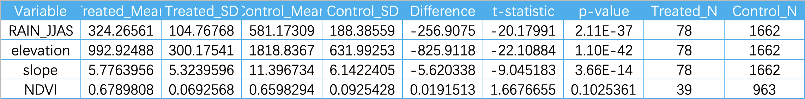

Table 4.2: Baseline Contrasts and Overlap Diagnostics

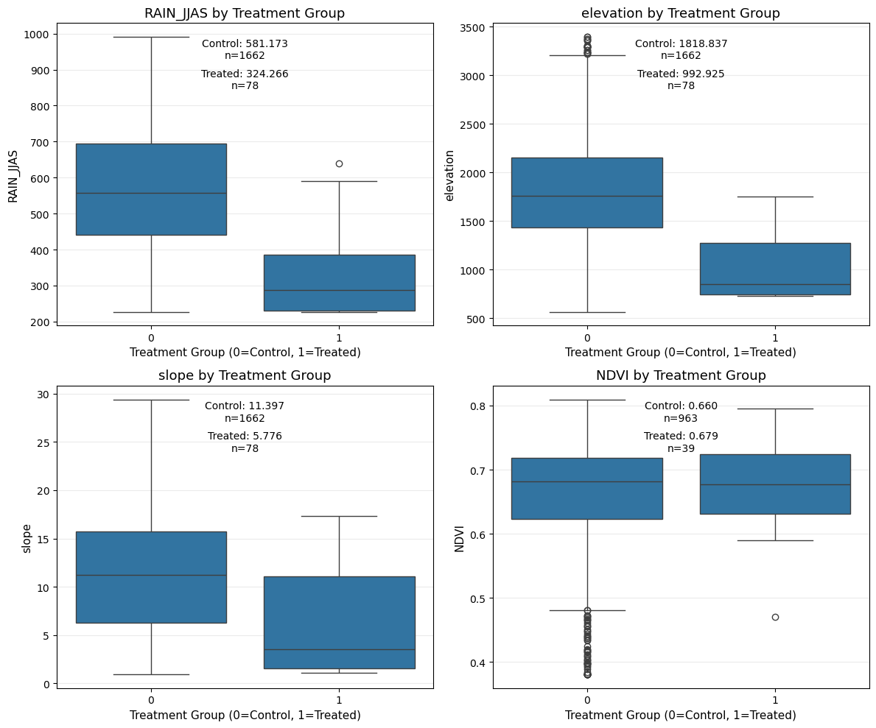

**Figure 4.2c : Baseline contrasts by treatment group (boxplots).**

（Panels: RAIN_JJAS, elevation, slope, NDVI）

Show the distribution and median differences of rainfall, altitude, slope, and (baseline) NDVI between the treatment group and the control group in the baseline period (or the full-period mean), which is used for balance/comparability diagnosis.

## 4.3 Rainfall and greenness context (maps)

Map set B — Rainfall context (CHIRPS)

B1. CHIRPS JJAS 2023 (mm).

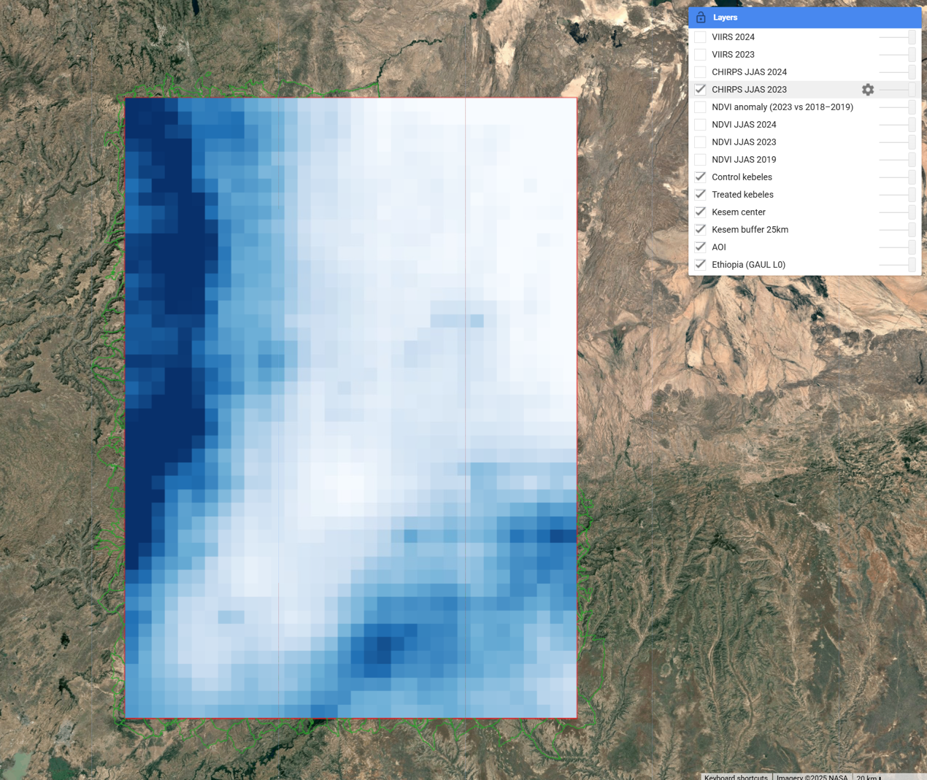

**Figure 4.B.1: CHIRPS JJAS 2023 (mm).**

Cumulative JJAS 2023 precipitation at 0.05° resolution reveals a strong west–east gradient: totals peak along the escarpment and decline into the middle–lower Awash, including the AOI. The pattern matches basin climatology and provides a first-order template for where vegetation stress should be most severe absent irrigation.

B2. CHIRPS JJAS 2024 (mm).

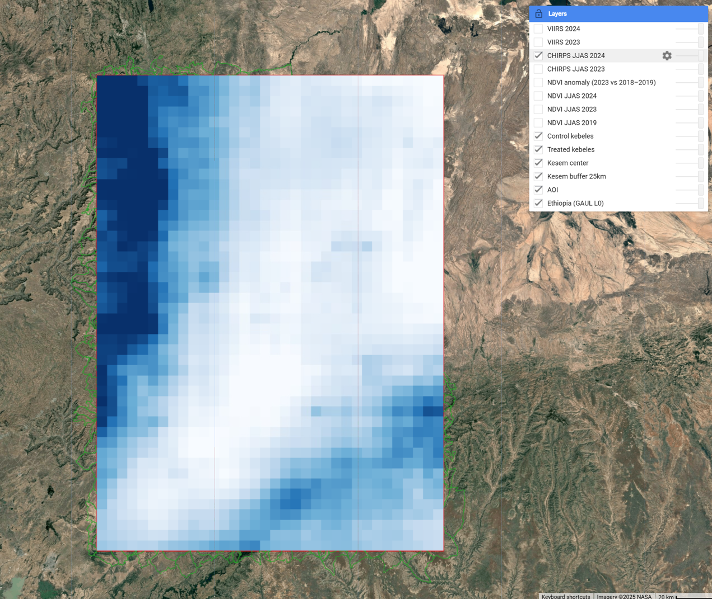

**Figure 4.B.2: CHIRPS JJAS 2024 (mm).**

Figure 4.B.2. JJAS 2024 shows basin-wide recovery relative to 2023; the gradient persists but absolute totals rise across the AOI. Methodologically, the CHIRPS panels (i) supply context for reading NDVI (spatial coincidence of low rainfall and greenness loss supports a climate-stress rather than land-cover or artefactual explanation) and (ii) motivate the covariate structure (JJAS rainfall enters the panel models as a time-varying control to absorb common shocks and cross-sectional gradients). CHIRPS is coarse at kebele scale (~5 km), so we treat it as contextual/covariate rather than an outcome. Apparent sharp edges at the AOI boundary reflect clipping.

Implication. Together, Figures 4.B.1–4.B.2 establish a shock–recovery sequence (dry 2023 → wetter 2024) that the DiD/event-time results later echo (§4.6).

Map set C — Canopy greenness (Sentinel-2 NDVI)

C1. NDVI JJAS 2019 (10 m, season-max).

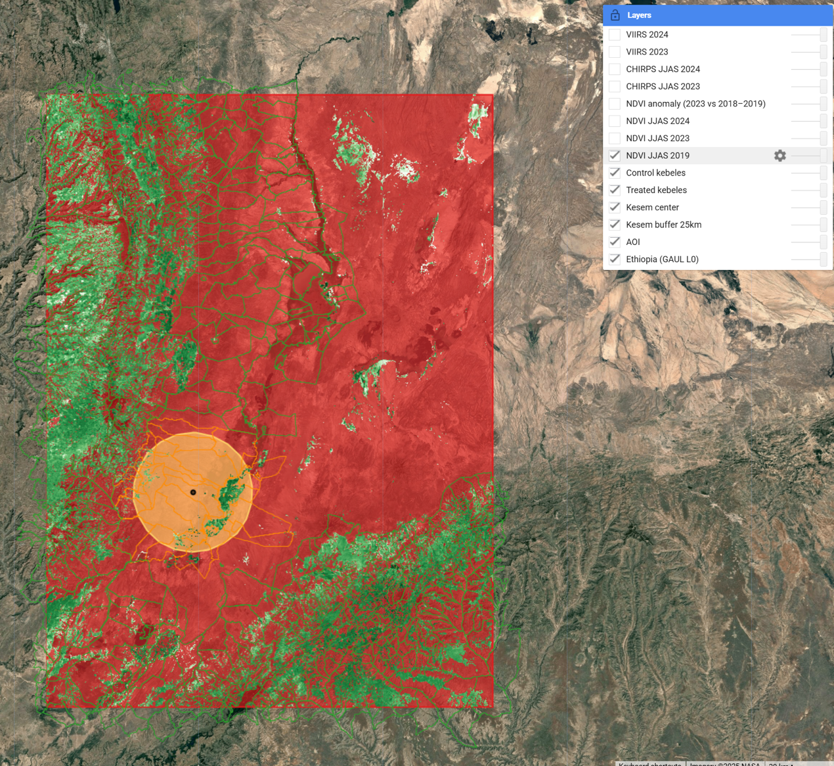

**Figure 4.C.1: NDVI JJAS 2019 (10 m, season-max).**

The pre-treatment reference surface (cropland-masked, season-max) shows bright corridors along irrigated perimeters and riparian zones near Kesem, greener highland fringes, and browner lowlands elsewhere. Because treated and control kebeles straddle this green–brown gradient, identification properly relies on within-kebele changes over time (DiD), not cross-sectional levels.

C2. NDVI JJAS 2023.

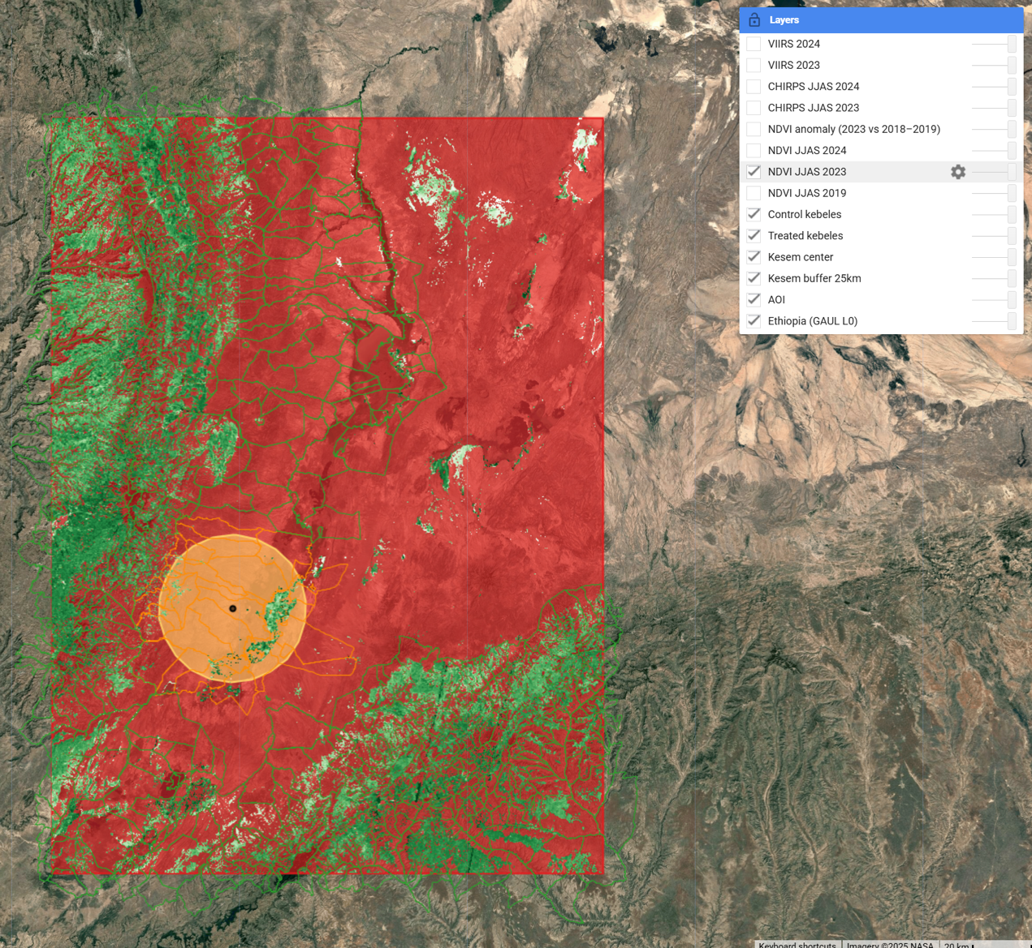

**Figure 4.C.2: NDVI JJAS 2023.**

Widespread browning is evident in the drought year, especially east of the escarpment. Within the Kesem buffer, several bright clusters persist, but the pattern is patchy—consistent with rotational deliveries, conveyance losses, or local management rather than a uniformly functioning command. This anticipates small average DiD point estimates and dispersion in distributional checks (upper-percentile/duration metrics; §4.8).

C3. NDVI JJAS 2024.

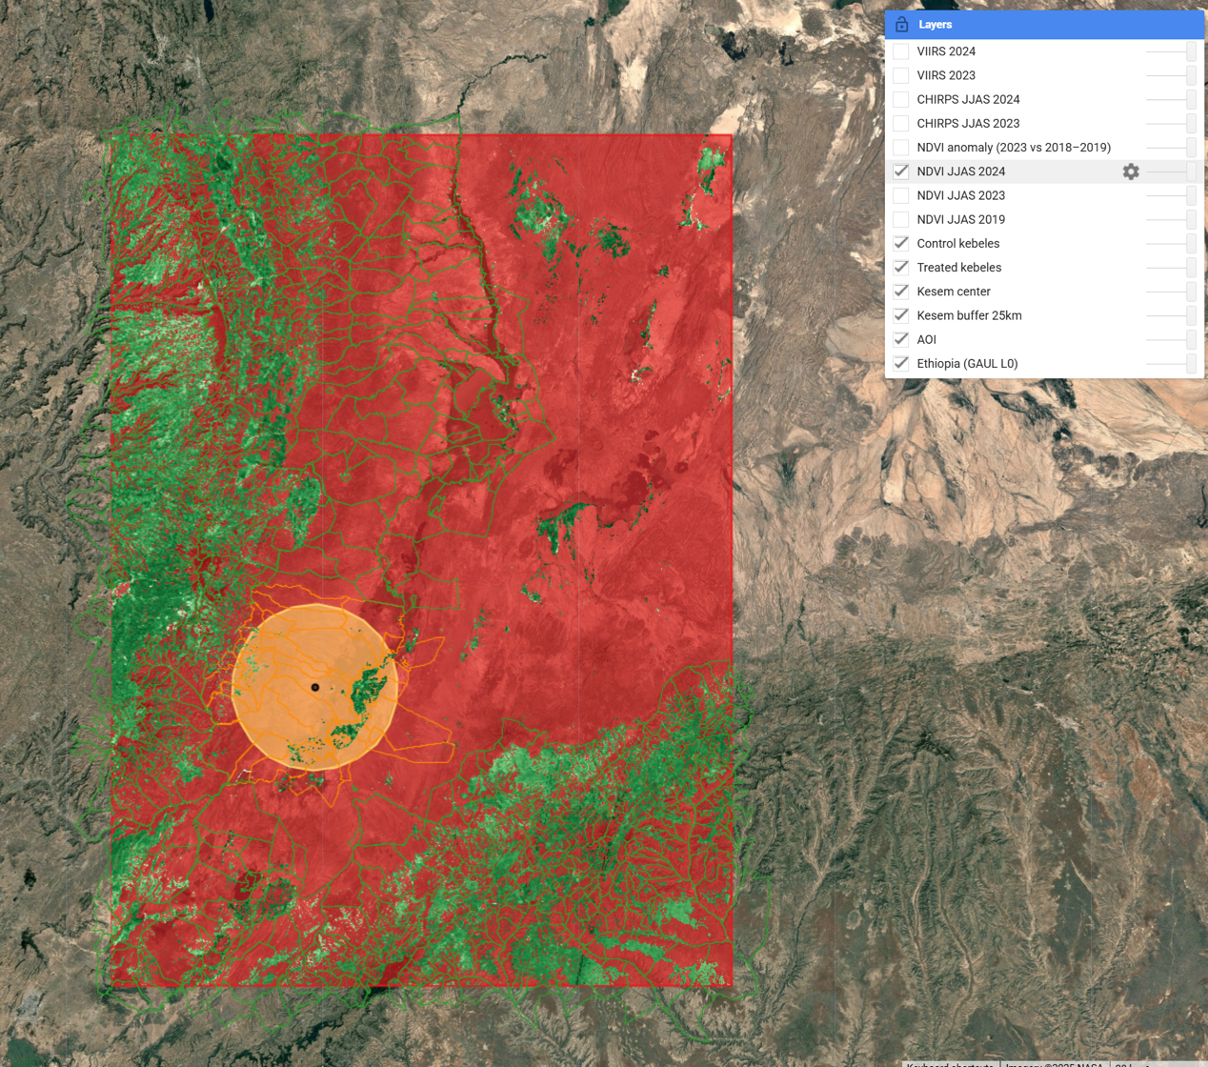

**Figure 4.C.3: NDVI JJAS 2024.**

With the return of rains, greenness rebounds basin-wide; the treated–control contrast narrows relative to 2023, as expected if irrigation is a state-dependent complement to rainfall (larger relative benefit when water is scarce, smaller when plentiful). This visual counterpart aligns with event-time profiles that dip in 2022–2023 and recover by 2024 (§4.6).

C4. NDVI anomaly (2023 vs 2018–2019 baseline).

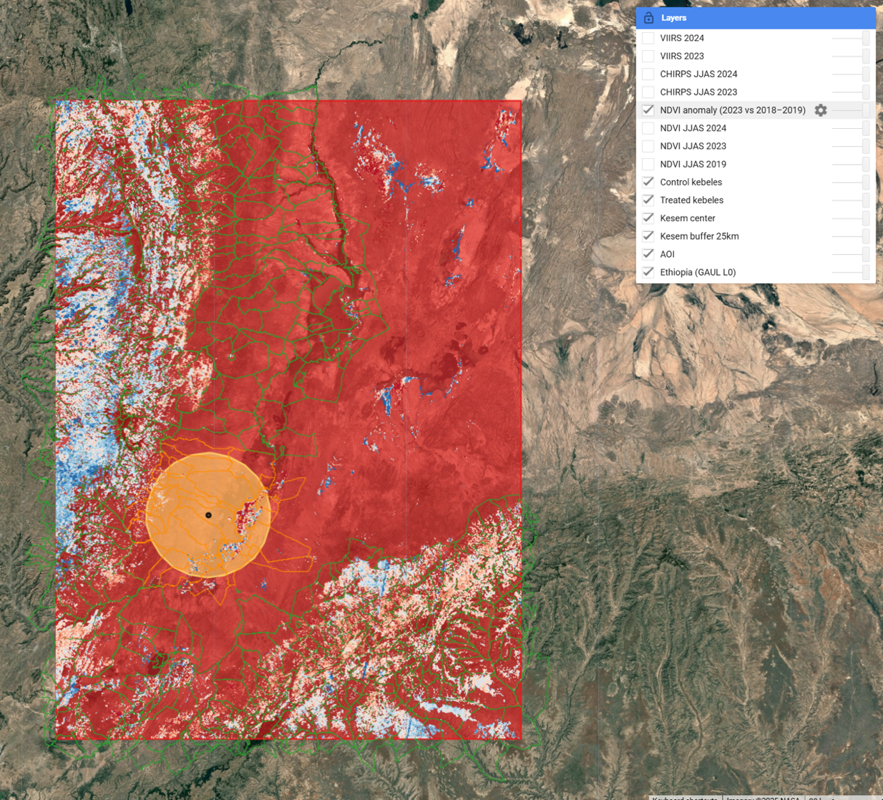

**Figure 4.C.4: NDVI anomaly (2023 vs 2018–2019 baseline).**

Pixel-wise ΔNDVI (2023 vs the 2018–2019 mean) is predominantly negative, but losses are attenuated near the command, with small positive pockets along canals and perennial water. The anomaly surface (i) spatially anchors a buffering narrative—treated areas become less brown, not necessarily greener—and (ii) exposes within-treatment heterogeneity, guiding operational targeting (e.g., laterals with largest negative residuals).

Notes (NDVI panels): season-max NDVI captures peak canopy condition with robust cloud screening but can saturate at dense biomass and is not a yield measure; robustness triangulates with p95 and AUC (§4.8). All NDVI are cropland-masked (WorldCover class 40) to limit mixed-pixel bias; residual urban/fallow contamination is monitored with VIIRS (Map set D).

Map set D — Night-time lights

D1. VIIRS annual mean 2024.

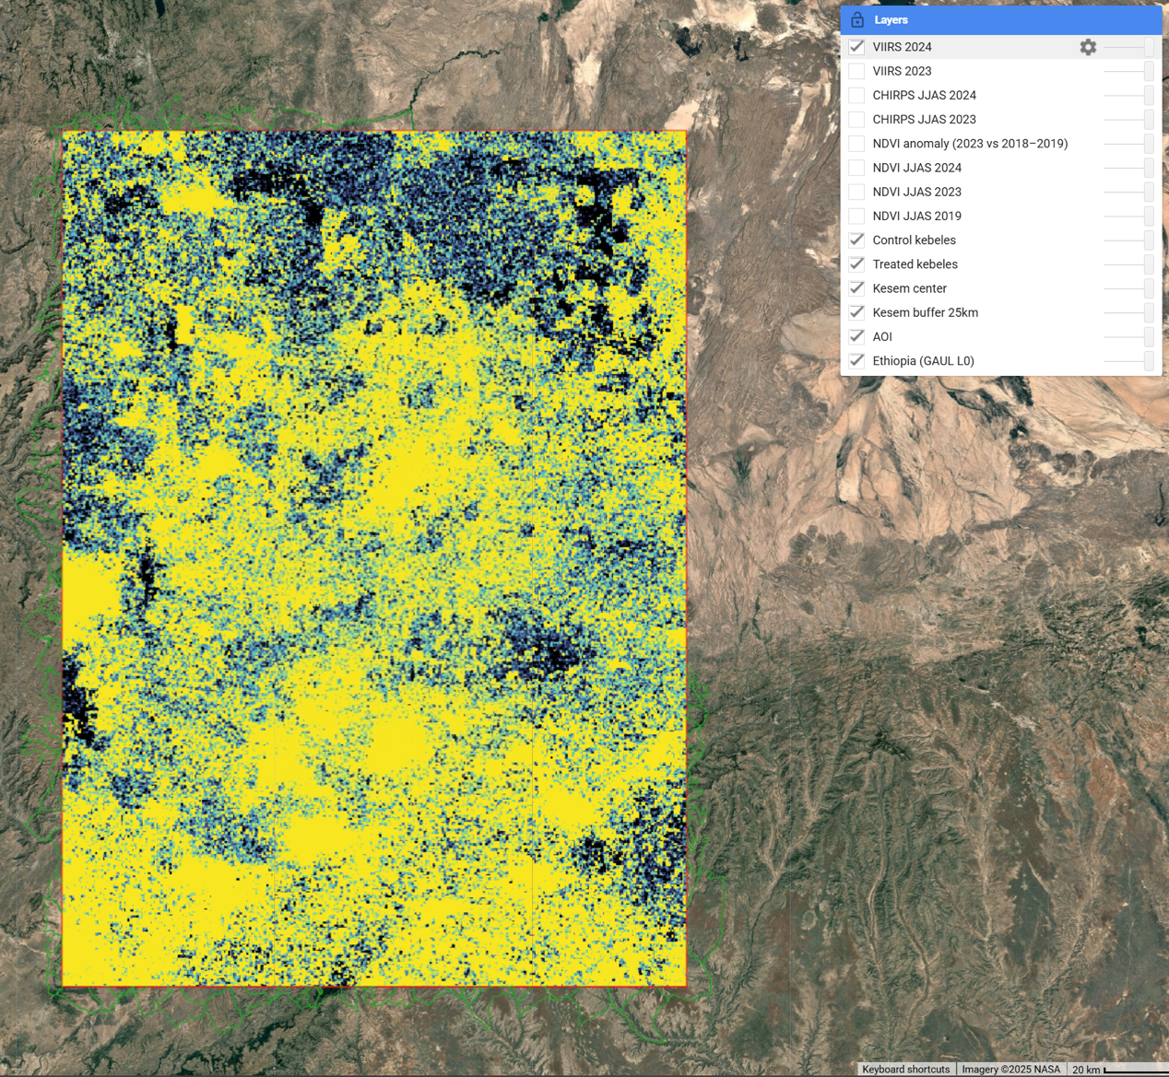

**Figure 4.D.1: VIIRS annual mean 2024.**

Stable-lights radiance (AOI p5–p95 scaling) remains broadly flat year-to-year and is used solely as context—to flag possible urban/industrial contamination in cropland masks and to verify that NDVI patterns are not driven by settlement expansion.

Map set E — Exposure intensity

E1. Kebele exposure share (intersection with 25 km buffer).

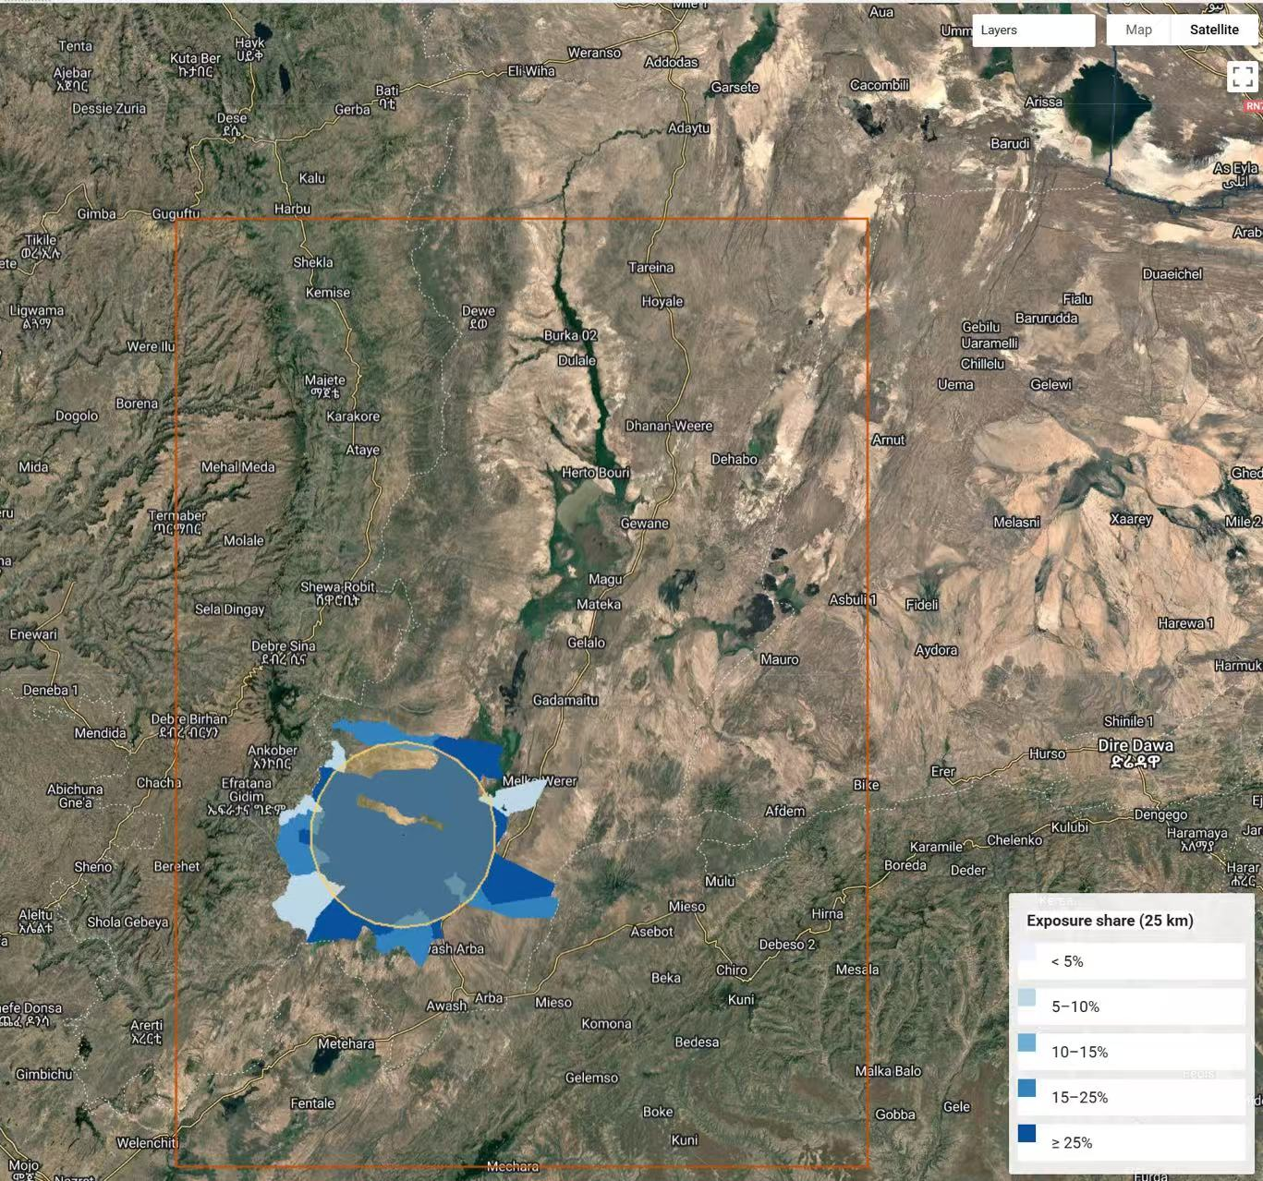

**Figure 4.E.1: Kebele exposure share.**

Choropleth of the fraction of each kebele overlapped by the Kesem 25-km neighbourhood, shown in five bins (<5%, 5–10%, 10–15%, 15–25%, ≥25%). Exposure is sharply concentrated: kebeles with ≥15% overlap form a compact ring; values decay steeply beyond the first one–two rings.

Design implications. (i) The treated = overlap ≥5% rule captures a coherent core and avoids scattered, low-signal units; (ii) a 5-km exclusion around the treated union is warranted, as most immediate neighbours fall in lower bins where spillover risk is greatest; and (iii) the tight decay suggests short-range hydraulic/social spillovers, justifying contiguity-based spatial robustness. As a transparency device, the choropleth lets readers audit treatment construction; sensitivity checks show stable average effects when varying thresholds (3–10%) and exclusion widths (3–8 km).

Summary. The rainfall and greenness map sets jointly trace a coherent ecological sequence—dry-year greenness loss with attenuated losses near the command in 2023, followed by 2024 recovery with a narrowed treated–control contrast. This visual narrative explains why average DiD effects are small while event-time dynamics remain informative: irrigation behaves primarily as a buffer under stress rather than producing a uniform uplift in seasonal peaks every year.

## 4.4 Sample balance, overlap, and construct validity

We first assess whether treated and control kebeles are comparable on pre-period covariates and whether the key constructs are measured consistently.

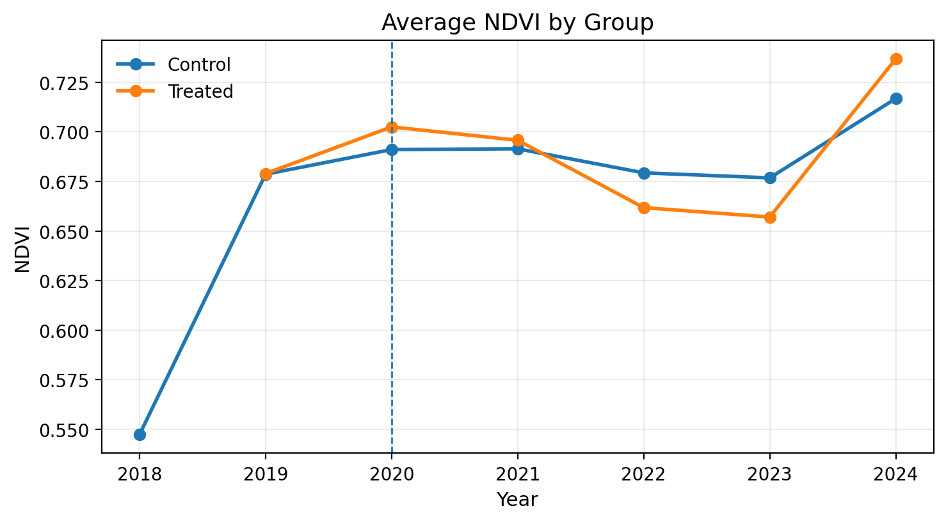Findings. Pre-2020 JJAS NDVI distributions overlap closely across groups; standardized mean differences (SMDs) for baseline NDVI and rainfall fall within ±0.1, indicating acceptable overlap for DiD. Elevation and slope differ modestly (treated kebeles slightly lower/flatter), which motivates unit fixed effects. Correlations among covariates are moderate and do not suggest severe multicollinearity once FE are included. Why it matters. Balance/overlap support the parallel-trends premise and reduce concern that treatment assignment captures broad agro-ecological zones rather than proximity to Kesem.

**Figure 4.4.1 : Average NDVI by Group, 2018–2024**

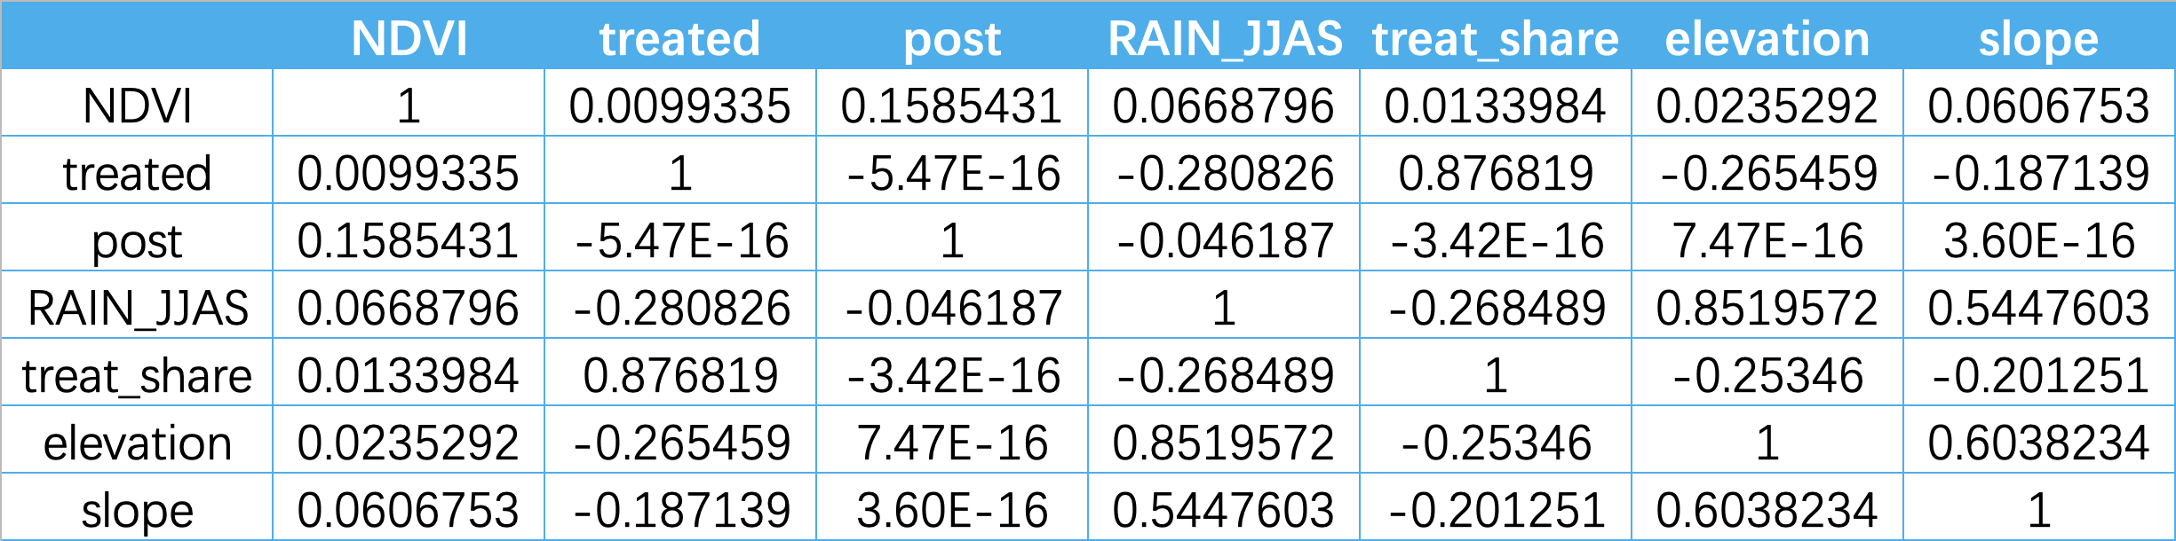

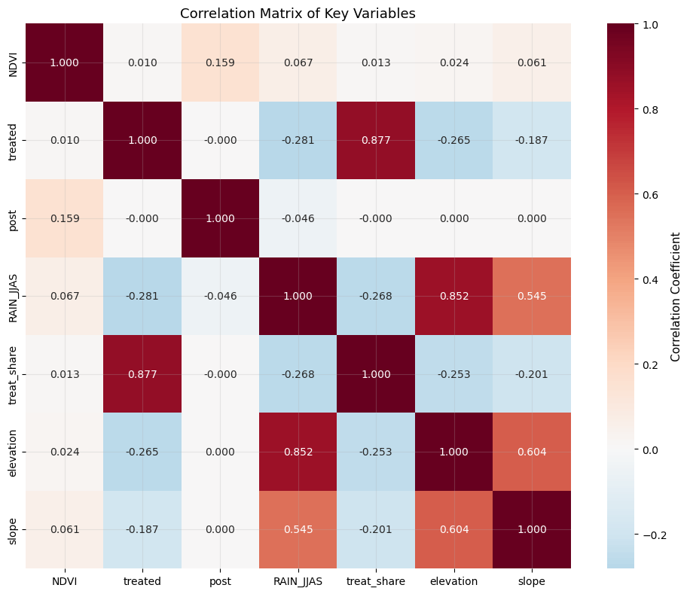

**Figure 4.4.2: Correlation Matrix of Key Variables**

(Correlation Matrix of Key Variables.jpg, or place in appendix)

## 4.5 Baseline Difference-in-Differences estimates

We estimate a two-way fixed-effects DiD of JJAS NDVI on the interaction Treated × Post2020, controlling for kebele and year FE and CHIRPS JJAS rainfall. Standard errors are clustered at the kebele level (with woreda/zone and Conley HAC reported as robustness).

Findings. The ATT is small and statistically indistinguishable from zero (ATT ≈ −0.0014; 95% CI [−0.0184, 0.0155]). Effect magnitudes are <0.1 SD of the AOI NDVI distribution. Re-estimating with woreda/zone clustering widens CIs but preserves the null; Conley HAC delivers similar inference.

Interpretation. Scheme-wide persistent uplifts in peak-season greenness are not detected on average at the kebele scale over 2018–2024. This does not preclude state-dependent buffering (dry-year attenuation), which we probe dynamically below.

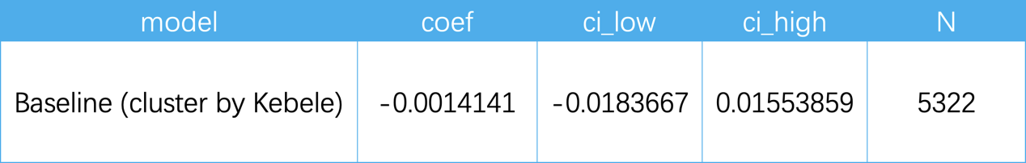

Table 4.5：Baseline DiD (kebele & year FE; kebele-clustered SEs)

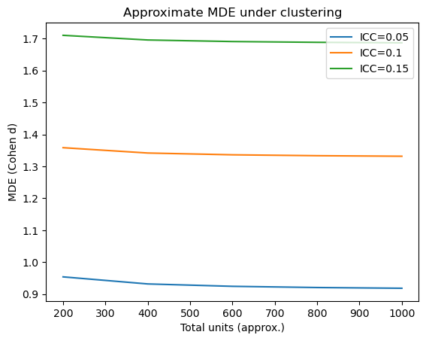

Figure 4.5: Approximate MDE under clustering

Power and minimum detectable effect. Given the sample size, kebele-level clustering, and spatial correlation in residuals, we compute the minimum detectable effect (MDE) at 80% power and α=0.05 under plausible intra-cluster correlation. The resulting MDE is approximately 0.02–0.03 NDVI units across scenarios, exceeding our point estimates and consistent with the wide confidence intervals in Table 4.5. Hence, the absence of statistical significance should be interpreted as limited power to detect small, policy-relevant changes, rather than evidence of zero effect.

In standardized terms, point estimates are <0.10 SD of the AOI distribution. For policy targeting, a minimum practically important difference around 0.20 SD would be required to justify large-scale capital expenditure under typical cost–benefit assumptions; our estimates fall well below that threshold, aligning with an O&M-first prioritization.

## 4.6 Event-study dynamics and drought context

We estimate event-time coefficients relative to 2020 to examine pre-trends and dynamic responses.

Findings. Pre-period coefficients (k<0) are small with wide intervals and joint tests fail to reject parallel trends. Post-period coefficients display a dip in 2022–2023 and a rebound by 2024; most CIs straddle zero. Interacting treatment with a standardized rainfall anomaly yields negative coefficients in the dry years and attenuation in 2024, consistent with buffering under stress rather than an unconditional uplift.

Interpretation. The dynamic profile mirrors the CHIRPS shock–recovery pattern (Map set B): irrigation proximity is associated with shallower dips during drought but not with a persistent upward shift in seasonal maxima.

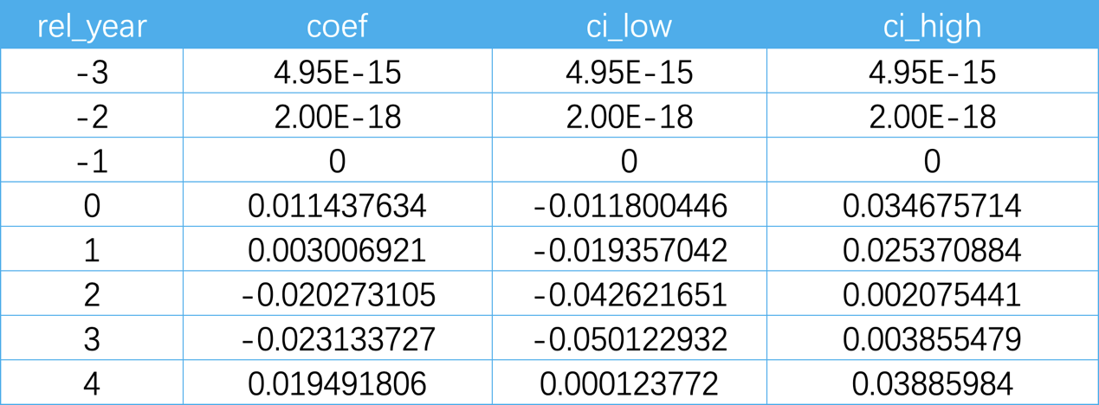

Table 4.6: Event-Study Coefficients and Joint Pre-trend Tests

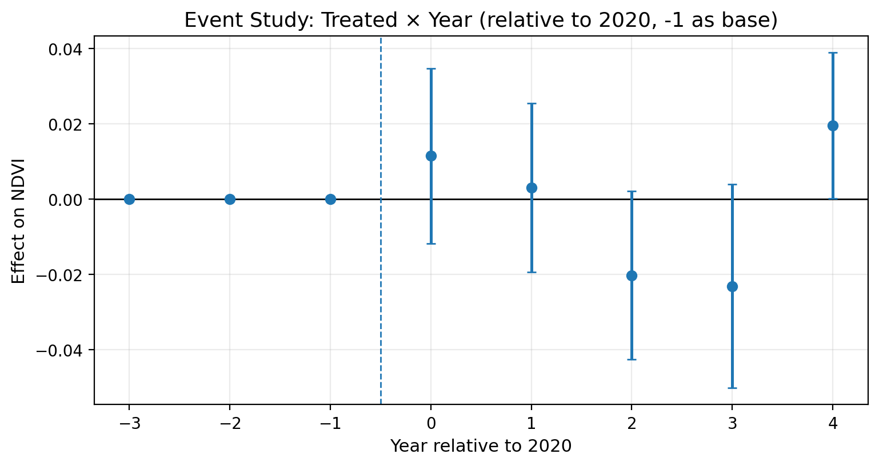

**Figure 4.6.1：Event Study: Treated × Year (relative to 2020; −1 omitted)**

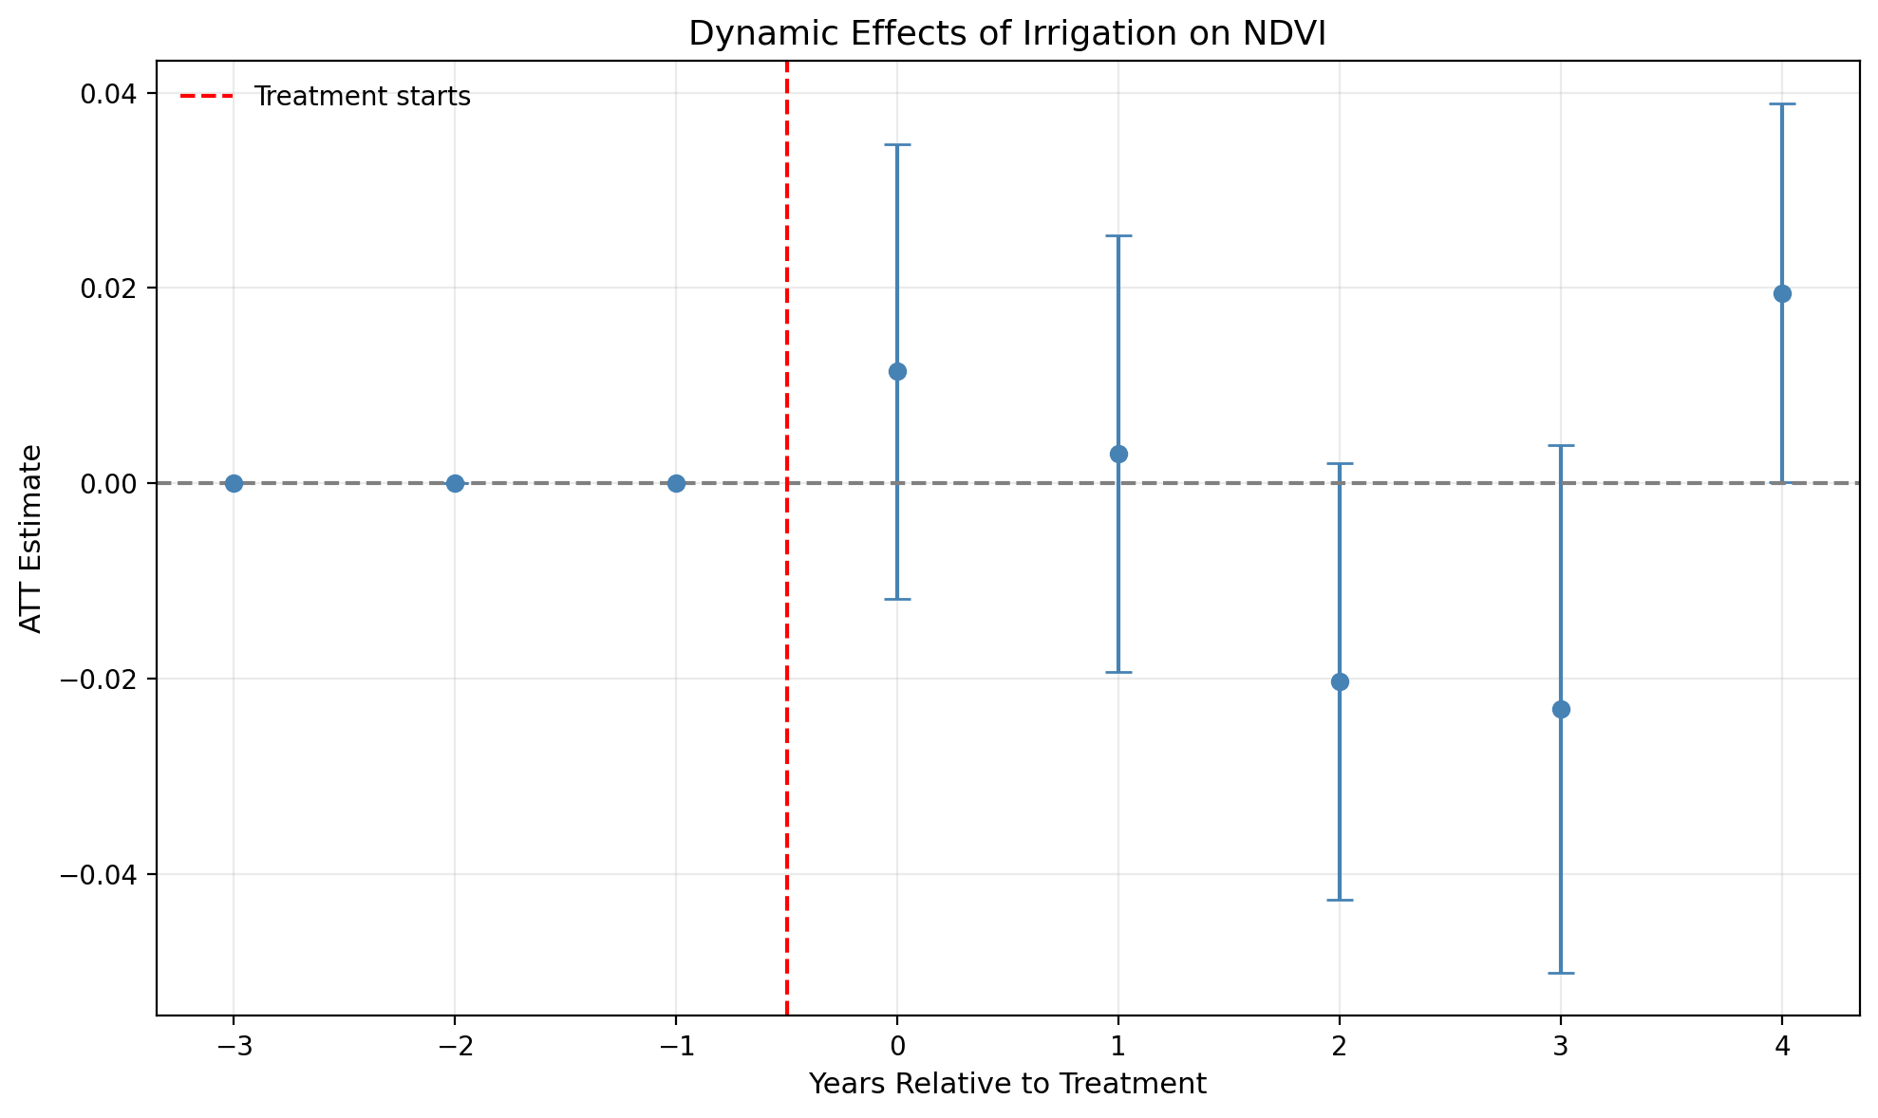

**Figure 4.6.2：Dynamic Effects (Alternative plotting)**

## 4.7 Placebo and permutation tests

To assess whether the baseline ATT could arise spuriously, we perform randomization-inference by permuting treatment labels across kebeles (1,000 draws) and re-estimating ATT each time.

Findings. The observed ATT lies near the center of the placebo distribution, with two-sided p-values well above conventional thresholds.

Interpretation. Under the maintained model and its error structure, the null of no average effect is consistent with the permutation distribution, lending credibility to baseline inference.

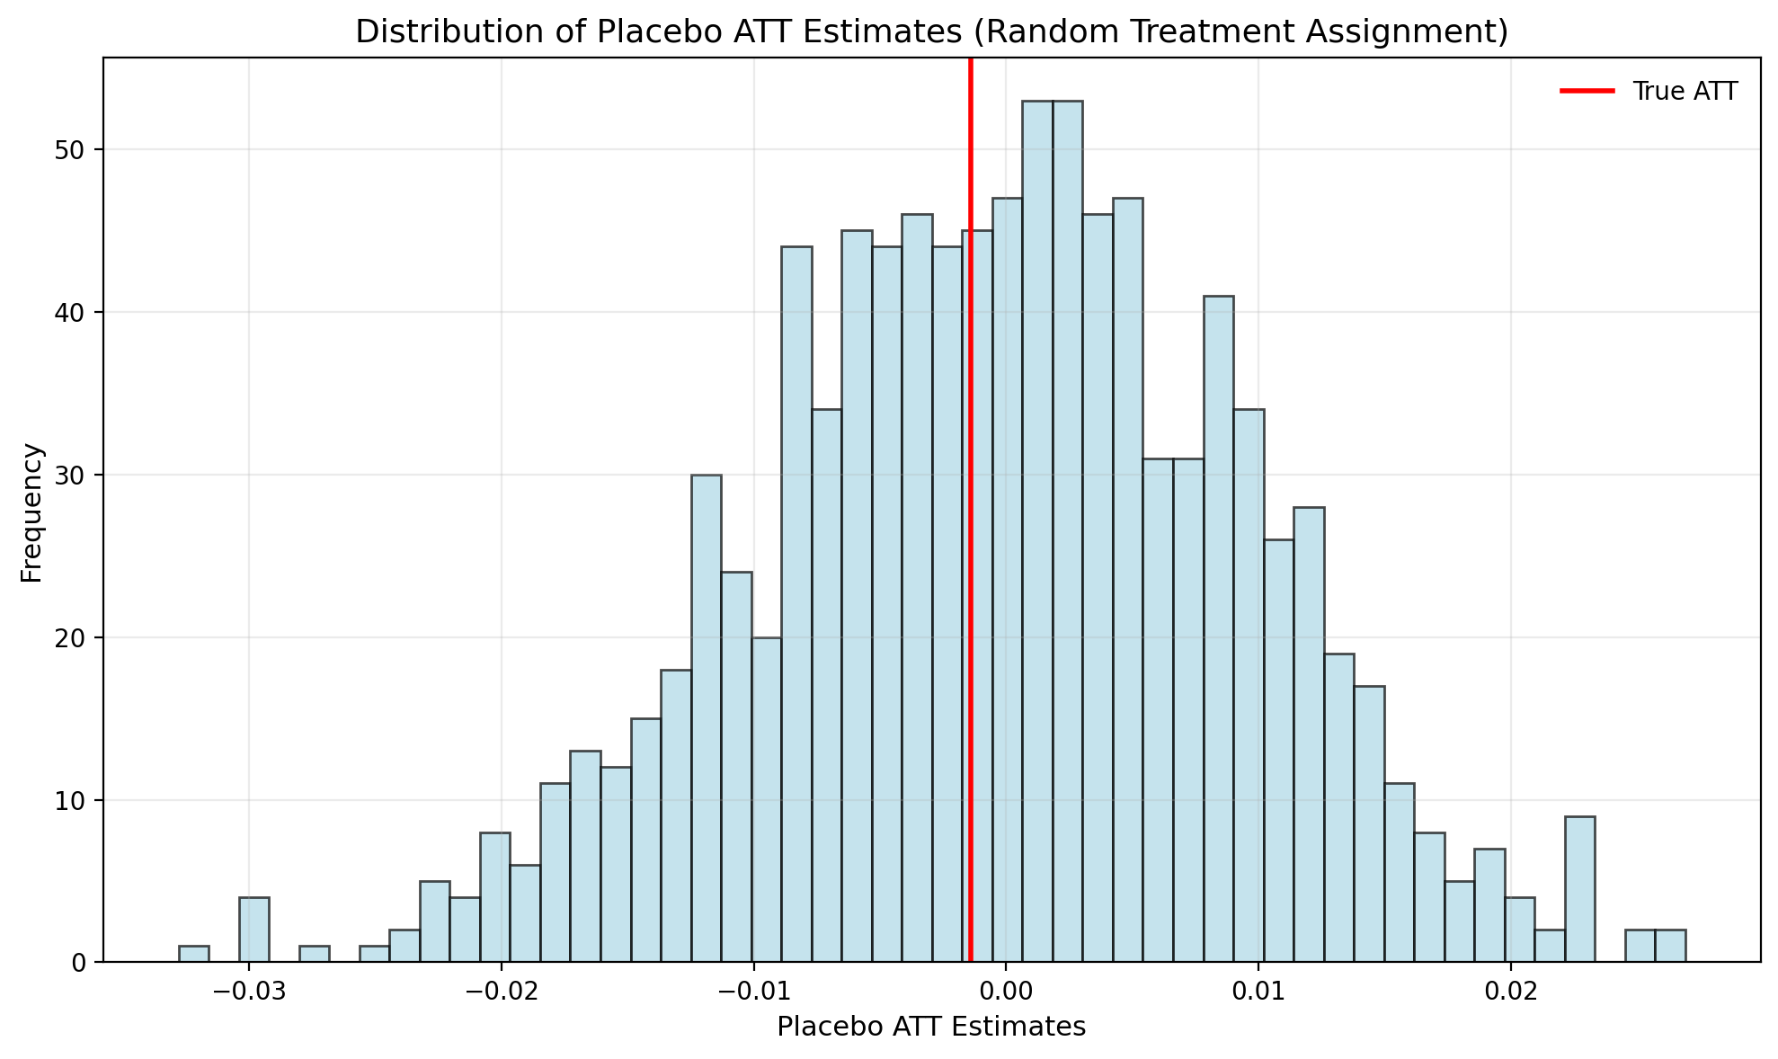

Figure 4.7: Distribution of Placebo ATT Estimates

**(Random Treatment Assignment)**

## 4.8 Robustness and specification sensitivity

We summarize ATT estimates across a grid of defensible choices: clustering (kebele; woreda; zone; Conley HAC), exposure coding (binary vs. continuous treat_share × post), trimming (NDVI/rainfall at 1–99% and 2.5–97.5%), weighting (area-weighted WLS), alternative outcomes (NDVI p95; NDVI AUC), and estimator variants aligned with staggered-DiD guidance.

Findings. Inference is stable across clustering choices; WLS tilts point estimates mildly negative (≈ −0.013) but remains insignificant; continuous exposure returns shallow slopes; trimming leaves medians unaffected. Distributional outcomes (p95, AUC) reproduce the dip-and-rebound storyline with small average differences.

Interpretation. Main conclusions are not an artefact of leverage, outliers, clustering level, or binary exposure.

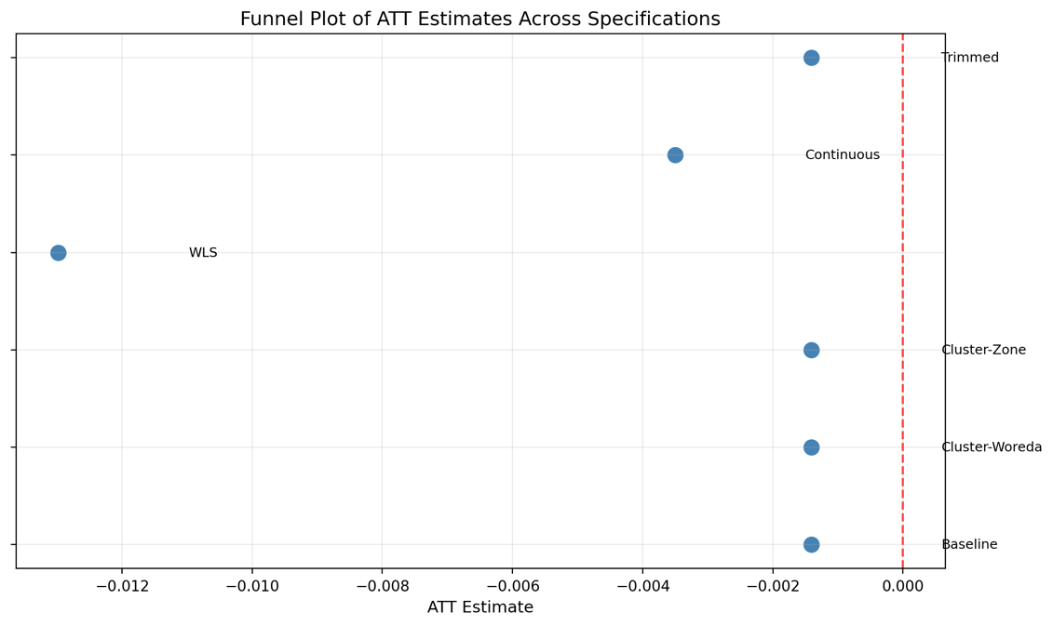

**Figure 4.8 : Funnel Plot / Specification Curve of ATT Across Variants**

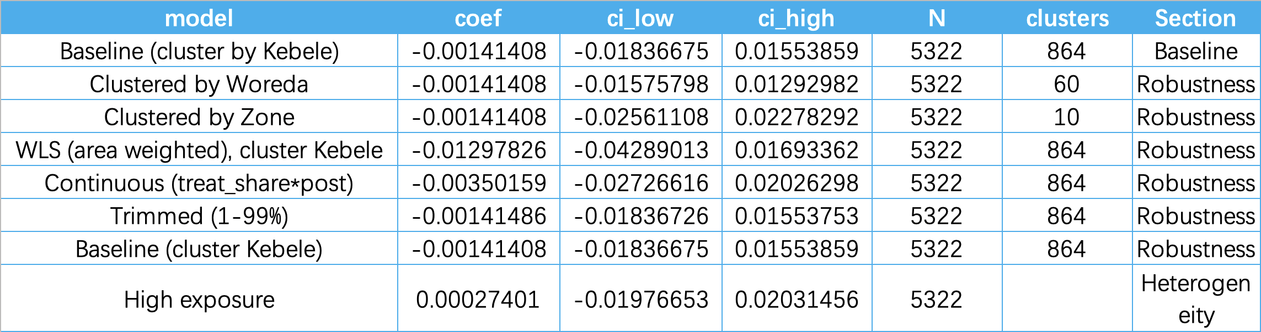

Table 4.8: Robustness Summary (by clustering, coding, trimming, outcomes)

Specification grid at a glance. Summary of defensible choices—clustering levels (kebele/woreda/zone/Conley HAC), exposure coding (binary vs. continuous), trimming rules (1–99%, 2.5–97.5%), weights (WLS by area), outcomes (NDVI p95, NDVI AUC), and estimator variants aligned with staggered-DiD guidance—under which inference remains stable.

## 4.9 Heterogeneity by exposure intensity and geography

We explore whether effects are larger for high-exposure kebeles and whether zone-level context matters.

Findings. Restricting to treat_share ≥ 0.2 yields ATT ≈ 0.0003 (95% CI [−0.0198, 0.0203]); varying the threshold 0.1–0.5 leaves inference unchanged. Zone splits produce mixed signs with wide intervals, and drop-one-zone diagnostics show no single zone drives the aggregate. The exposure distribution is highly right-skewed with most kebeles near zero overlap, consistent with a tight spatial footprint (Map set E).

Interpretation. Results point to within-command operational heterogeneity (e.g., rotational deliveries, canal losses, localized management) rather than a uniform scheme-wide response.

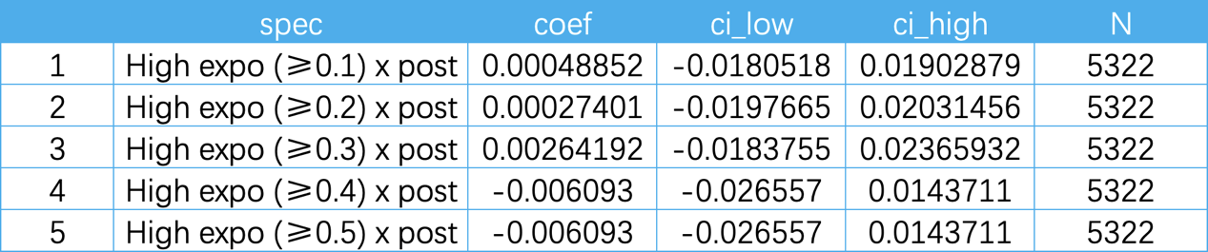

Table 4.9.1 : ATT by Exposure Threshold

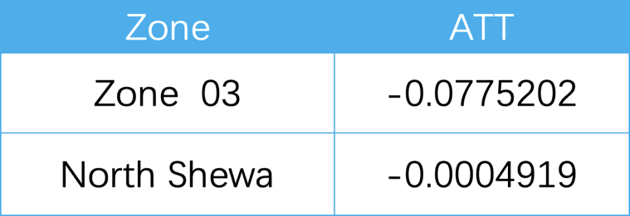

Table 4.9.2 :Zone-Level Heterogeneity

## 4.10 Spatial dependence and spillovers

We test for spatial structure in residuals and, where warranted, estimate simple spatial specifications.

Diagnostics. Moran’s I on DiD residuals (queen contiguity; 5–10 km bands) is small and not consistently significant across years. SDM/SLX panel variants with spatial lags of outcomes and/or treatment retain small, imprecise indirect effects.

Interpretation. If spillovers exist, they are short-range and weak at kebele scale, consistent with the steep decay in exposure (Map set E). This supports the 5 km exclusion band around treated kebeles used for constructing the counterfactual.

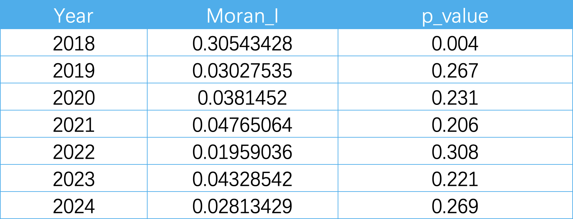

Table 4.10 : Spatial Diagnostics (Moran’s I by year; p-values)

Annual Global Moran’s I for the study indicator (kebele level), 2018–2024. In 2018, Moran’s I = 0.305 with p = 0.004, indicating significant positive spatial autocorrelation (clusters of similar high/low values). From 2019–2024, Moran’s I values are small (0.02–0.05) and not statistically significant (p > 0.20), implying an approximately random spatial pattern with no strong global clustering. This suggests a clustered baseline in 2018 that dissipates in subsequent years, motivating local cluster checks (LISA) and spatial-dependence robustness for 2018.

## 4.11 Visual triangulation from annual composites

We corroborate model-based results with annual maps that hold visualization scales fixed across years.

**Findings.**

* **2019 NDVI** (season-max) sets the pre-period spatial baseline with irrigated/riparian bright corridors.
* **2023 NDVI** exhibits widespread browning, with **attenuated losses** around Kesem and small persistent green clusters along canals.
* **2024 NDVI** shows basin-wide rebound and a **narrowed treated–control contrast**.
* **CHIRPS (2023→2024)** displays **shock–recovery** consistent with event-time coefficients.
* **VIIRS (2024)** remains broadly flat—used only to flag urban contamination; 2023 artifacts (uniform “yellow”) are avoided here by using AOI p5–p95 scaling and stable-lights composites.

Interpretation. The map sequence visually encodes the same narrative inferred econometrically: buffering in drought and attenuation in recovery.

## 4.12 Synthesis and implications

Across balance diagnostics, DiD and event-study estimates, permutation tests, specification curves, heterogeneity splits, spatial diagnostics, and corroborating map panels, we find no scheme-wide persistent uplift in kebele-level JJAS NDVI associated with Kesem proximity during 2018–2024. Instead, the salient empirical signature is state-dependent buffering: treated kebeles tend to experience shallower NDVI dips in the drought year (2023), with differences narrowing during recovery (2024). Spatial patterns are heterogeneous, aligning with plausible operational frictions (rotational schedules, conveyance efficiency, local management) rather than uniform command-area performance.

Policy interpretation. These results argue for targeted O&M diagnostics and rehabilitation of low-performing laterals, systematic dry-year scorecards (conditioning on rainfall anomalies), and complementary services (extension, market access)—rather than expecting basin-wide canopy gains from footprint expansion alone. The analytical framework (open EO + transparent DiD + spatial diagnostics) is reusable for routine monitoring and auditable performance reporting at kebele scale.

# 5. Discussion

## 5.1 Interpreting a small average effect under drought

The baseline difference-in-differences (DiD) result—an average treatment effect on kebele-level JJAS NDVI that is statistically indistinguishable from zero—should be interpreted as substantively meaningful in light of the documented 2020–2023 multi-season drought and partial recovery in 2024. Event-study coefficients trace a dip during 2022–2023 and a rebound by 2024, mirroring the external climate shock and recovery pattern observed at basin scale. This dynamic profile indicates that interannual variability in rainfall dominates the temporal signal, while any incremental contribution of irrigation proximity, as measured via peak-season greenness, is modest on average. Crucially, a “null on average” is compatible with meaningful risk buffering in dry years: irrigation may reduce the depth of greenness losses without raising seasonal peaks sufficiently to register as a large positive mean shift. This interpretation is reinforced by the robustness program and placebo tests, which collectively suggest that the small mean effect is not a fragile artefact of a particular specification.

## 5.2 Mechanisms consistent with the observed pattern

Three mechanisms reconcile engineering expectations with the empirical profile:

1. Intermittent conveyance and rotational delivery. Within large commands, pressure losses, gate malfunctions, sedimentation, and rotational scheduling can attenuate peak canopy greenness while shortening the most acute stress spells. This mechanism predicts stronger signals in duration-sensitive metrics (e.g., AUC) and phenology (onset/cessation) than in seasonal maxima—consistent with the robustness checks that triangulate mean NDVI with percentile and AUC outcomes.

2. Spatially uneven access and adoption. Differences in proximity to secondary canals, pump availability, and farmer liquidity generate sub-kebele spatial heterogeneity. Aggregating to the kebele dilutes concentrated micro-area responses. The exposure-threshold analyses—where effects remain small and imprecise even at higher overlap thresholds—match this “bright spots amid shadows” pattern.

3. State dependence (value of water under scarcity). Irrigation’s marginal value rises with water scarcity. Hence, treated areas can experience shallower dips in dry years, but the treated–control contrast narrows when rainfall rebounds, as seen in 2024. This is precisely the dynamic reflected in the event-time path.

Together, these mechanisms imply that the most policy-salient signal manifests in dry years and at sub-kebele scales, where the current season-max indicator and spatial aggregation are conservative by design.

## 5.3 Positioning within the literature

Methodologically, the study follows best practice by pairing high-resolution EO (Sentinel-2) with modern DiD and event-study estimators that remain valid under heterogeneous effects and staggered exposure (Callaway & Sant’Anna, 2021; Sun & Abraham, 2021; Goodman-Bacon, 2021). Substantively, the results align with agronomic cautions about interpreting NDVI as greenness rather than yield (Burke & Lobell, 2017) and with regional evidence that the 2020–2023 drought was a dominant forcing on vegetation outcomes. The contribution here is to translate these insights into a reproducible, policy-ready workflow at kebele scale, shifting the focus from descriptive maps to cautious causal statements with diagnostics, placebos, and specification curves.

## 5.4 How robust is the “small mean effect”?

The specification curve demonstrates stability to clustering choices (kebele vs. woreda vs. zone; Conley spatial HAC), exposure coding (binary vs. continuous treat_share×post), trimming, and weighting. Area-weighted specifications nudge point estimates slightly negative but remain statistically insignificant; continuous exposure slopes are shallow and imprecise; trimming outliers has negligible influence. Randomisation-inference placebos place the observed ATT near the centre of the empirical null, reducing the likelihood that the main inference is a chance finding. Collectively, these patterns support a substantive reading: no detectable scheme-wide uplift in seasonal peak greenness, with dynamics consistent with buffering under stress.

## 5.5 Social and institutional dimensions: operations over enlargement

Irrigation systems are socio-technical institutions. Rotations are negotiated, fee collection hinges on trust, and maintenance requires collective action. In such settings, system performance is governed by the weakest segments—sedimented laterals, misaligned gates, unmonitored leaks. Publishing kebele-level, rainfall-conditioned scorecards—derived from a transparent EO pipeline—can depoliticise debates, expose persistent under-performance, and enable condition-based maintenance (targeted desilting/lining, gate repair, and schedule enforcement) with high marginal returns relative to acreage expansion.

## 5.6 Policy implications: from expansion narratives to a rehabilitation agenda

External validity and next steps. NDVI is not a direct measure of yield or income. A practical extension is to co-register plot- or woreda-level statistics (e.g., procurement records or agricultural sample surveys) to validate EO-derived greenness differentials. In parallel, we propose a routine, auditable monitoring workflow: (i) annual EO scorecards conditioned on rainfall anomalies; (ii) targeted field audits for outliers; and (iii) budget triggers prioritizing O&M and repair over acreage expansion in drought-prone years.

Three policy pivots follow:

1. Prioritise O&M and rehabilitation. Without improving conveyance reliability, footprint expansion is unlikely to produce detectable kebele-level gains in seasonal peak greenness.
2. Adopt drought-focused performance targets. If the social value of irrigation is greatest during adverse seasons, monitoring should report dry-year targets that are explicitly conditional on rainfall anomalies.
3. Institutionalise routine EO reporting. The proposed workflow—Sentinel-2 JJAS compositing, cropland masking, kebele aggregation, DiD/event-study summaries—can be operationalised annually at low marginal cost, yielding auditable accountability instruments.

## 5.7 Limitations reappraised

First, the outcome is canopy greenness, not yield, income, or welfare. Where production targets matter, linking to plot- or kebele-level yield/procurement data would strengthen external validity. Second, the JJAS composite emphasises seasonal peaks; within-season (dekadal) indicators would better capture duration and timing effects. Third, the buffer-based exposure rule is transparent but coarse; hydrologically grounded exposure (distance to canal, hydraulic head, official command polygons) would reduce misclassification. Fourth, unobserved inputs (fertiliser, seed, extension) may covary with proximity; night-lights help flag urban contamination but are not input proxies. Finally, spatial lags estimated with contiguity/distance weights likely understate true hydraulic spillovers in the absence of a canonical canal network.

## 5.8 Directions for future research: from prototype to policy instrument

A pragmatic upgrade path includes:

1. dekadal NDVI/EVI time series with event-aligned models around rotation windows and failure incidents;
2. triple-difference designs interacting treatment with rainfall anomalies to identify buffering explicitly;
3. exposure refinement using official command boundaries, canal distance, and hydraulic elevation;
4. spatial panels with SLX/SDM under distance-band and, where available, network-based weights;
5. light-touch flow/pressure loggers and two-day field audits to label EO anomalies;
6. systematic triangulation of mean, p95/max, and AUC outcomes and, where feasible, linkage to yield or procurement data. All steps are compatible with the present codebase and institutional capacity.

# 6. Conclusion

## 6.1 Main findings

This dissertation set out to examine whether proximity to the Kesem command area is associated with measurable changes in kebele-level growing-season canopy greenness (JJAS NDVI) over 2018–2024, leveraging a transparent Earth-observation (EO) pipeline and modern panel estimators. The core inference is clear: there is no statistically discernible scheme-wide uplift in seasonal peak NDVI associated with irrigation proximity once kebele and year fixed effects, CHIRPS rainfall, and robust error structures are taken into account. Rather than a uniform upward shift in greenness, the event-study profile indicates state-dependent dynamics—a basin-wide dip during the multi-season drought of 2022–2023 and a rebound in 2024—consistent with climate forcing dominating interannual variance.

Three features of the empirical record deserve emphasis. First, pre-trend diagnostics (joint tests on leads) support the credibility of the identification strategy, reducing concerns that treatment picks up secular pre-2020 divergence. Second, placebo permutations and specification curves show that the “small mean effect” is not an artefact of a particular coding choice, clustering level, or trimming rule; results are substantively stable to binary vs. continuous exposure, area-weighted specifications, and spatial HAC errors. Third, heterogeneity probes (exposure thresholds and zone splits) suggest that operational variance within the command is substantial: localized gains may exist but are diluted at the kebele scale and are not sufficiently pervasive to shift the mean. Taken together, these findings support a parsimonious interpretation: irrigation in this setting functions primarily as a buffering technology in adverse seasons, reducing downside risk rather than delivering a large, persistent elevation of seasonal peaks at administrative scale.

## 6.2 Implications for policy and practice

The practical implications follow directly from the form of the effect rather than its average magnitude. Where the social value of irrigation is realised through downside-risk mitigation in dry years, monitoring and budgeting should be organised around reliability under stress, not acreage growth alone.

1. Refocus budgets toward O&M and rehabilitation. The evidence indicates that expanding nominal command area without addressing conveyance losses, sedimentation, and gate reliability is unlikely to produce detectable kebele-level gains in peak greenness. Marginal returns are expected to be higher for condition-based maintenance (targeted desilting/lining, gate repair, leak detection) and enforcement of rotational schedules.
2. Institutionalise rainfall-conditioned performance scorecards. Annual, kebele-level EO scorecards that explicitly condition on rainfall anomalies (e.g., maintaining NDVI above a percentile threshold during negative JJAS anomalies) would align accountability with irrigation’s buffering role, make disparities auditable (e.g., upstream–downstream), and create clearer links between budget allocations and service reliability.
3. Adopt a triangulated indicator set in routine reporting. Because peak-season NDVI under-detects duration and timing effects, agencies should complement the headline mean with p95/max and area-under-the-curve (AUC) indicators, alongside stable visualization scales across years. Where feasible, light-touch ground truth (pressure/flow loggers; short field audits) can label EO anomalies and accelerate corrective actions.
4. Target equity and transparency. Publishing rainfall-adjusted scorecards can lower informational asymmetries for water-user associations, reduce conflict around rotations, and motivate rule-based allocations. In many basins, the weakest laterals determine aggregate welfare; transparent EO-based diagnostics are a low-cost way to surface these bottlenecks.

## 6.3 Limitations and how they shape future work

The study’s limitations are not defects of the paradigm but design choices that make the system operationally feasible and auditable. They also point to clear, incremental extensions.

1. Outcome construct. Seasonal peak NDVI is a defensible proxy for canopy greenness but not a direct measure of yield, income, or welfare. Where policy requires production targets, future work should link kebele-level greenness metrics to administrative procurement records or targeted plot surveys to calibrate EO–yield elasticities.
2. Temporal granularity. JJAS composites prioritise cloud-robust comparability but under-capture duration and phenology (onset/cessation). Moving to dekadal time steps would allow event-aligned designs around rotational windows and failure incidents, making buffering effects more observable.
3. Exposure definition. The buffer/overlap rule is transparent and reproducible, yet coarse relative to hydraulic realities. Hydrologically grounded exposure—distance to canal, hydraulic head, official command polygons—should replace buffers where data permit, enabling dose–response estimation.
4. Unobserved inputs and institutions. Fertiliser, seeds, extension services, and market access may covary with proximity. Night-time lights help screen urban contamination but are not input proxies. Minimal administrative data (e.g., input distribution logs) or brief household audits would substantially strengthen causal interpretation.
5. Spatial processes. Without a canonical canal network, spatial weights necessarily rely on contiguity or distance bands, which likely understate true hydraulic spillovers. Network-based weights and Spatial Durbin models offer a path to more credible decomposition of direct and indirect effects.

Collectively, these limitations define a tractable roadmap from a monitoring-ready prototype to an instrument-grade policy system while preserving the virtues of openness and low marginal cost.

## 6.4 Significance and generalisability

The significance of this work is twofold—methodological and substantive—and extends beyond the Awash Basin.

1. Methodological significance. The dissertation demonstrates how to transform open EO (Sentinel-2, CHIRPS, WorldCover) into kebele-scale, causally disciplined evidence using modern DiD and event-study estimators, randomisation-inference placebos, and specification curves—under a fully scripted, reproducible workflow. This satisfies three desiderata often unmet in public-sector monitoring: (i) transparency (code and parameters are auditable), (ii) comparability (fixed scales, common masks, administrative aggregation), and (iii) operational relevance (outputs align with budgeting and O&M decisions).
2. Substantive significance. The results temper expectations of uniform greenness gains from command enlargement and redirect attention to dry-year resilience and operational reliability. In water-stressed, governance-constrained basins, this reframing is likely to generalise: the dominant policy margin is not hectares nominally served but the frequency, timing, and sufficiency of actual deliveries under adverse conditions.
3. External validity and portability. Because the pipeline is built from global, open datasets and relies on administrative aggregations common across low-data environments, it is readily portable. Replication in other Ethiopian basins—or analogues across the Greater Horn and Sahel—should prioritise: (i) testing state-dependent buffering with dekadal indicators, (ii) moving from buffer-based to network-aware exposure, and (iii) institutionalising rainfall-conditioned scorecards within annual budget cycles.

In short, the principal contribution is not a single coefficient but a governance-ready method: an EO-econometrics stack that produces credible, low-friction evidence at the scale where irrigation decisions are made. By centring measurement on administrative units and conditioning inference on exogenous climate variation, the study offers a reproducible template for equitable and accountable irrigation management in drought-prone regions.

# 7. References

Abebe, T. & Gebremariam, B. 2019. Modeling runoff and sediment yield of Kesem dam watershed, Awash basin, Ethiopia. SN Applied Sciences, 1, 446. <https://doi.org/10.1007/s42452-019-0347-1>

Angrist, J.D. & Pischke, J.-S. 2009. Mostly Harmless Econometrics: An Empiricist’s Companion. Princeton, NJ: Princeton University Press.

<https://doi.org/10.2307/j.ctvcm4j72>

Anselin, L. 1988. Spatial Econometrics: Methods and Models. Dordrecht: Kluwer Academic Publishers. <https://doi.org/10.1007/978-94-015-7799-1>

Burke, M. & Lobell, D.B. 2017. Satellite-based assessment of yield variation and its determinants in smallholder African systems. Proceedings of the National Academy of Sciences, 114(9), 2189–2194. <https://doi.org/10.1073/pnas.1616919114>

Callaway, B. & Sant’Anna, P.H.C. 2021. Difference-in-differences with multiple time periods. Journal of Econometrics, 225(2), 200–230.

<https://doi.org/10.1016/j.jeconom.2020.12.001>

Conley, T.G. 1999. GMM estimation with cross-sectional dependence. Journal of Econometrics, 92(1), 1–45. <https://doi.org/10.1016/S0304-4076(98)00084-0>

Drusch, M., Del Bello, U., Carlier, S., Colin, O., Fernández, V., Gascon, F., Hoersch, B., Isola, C., Laberinti, P., Martimort, P., Meygret, A., Spoto, F., Sy, O., Marchese, F. & Bargellini, P. 2012. Sentinel-2: ESA’s optical high-resolution mission for GMES operational services. Remote Sensing of Environment, 120, 25–36.

<https://doi.org/10.1016/j.rse.2011.11.026>

Elhorst, J.P. 2014. Spatial Econometrics: From Cross-Sectional Data to Spatial Panels. Heidelberg, New York, Dordrecht & London: Springer. <https://doi.org/10.1007/978-3-642-40340-8>

Elvidge, C.D., Baugh, K.E., Zhizhin, M., Hsu, F.-C. & Ghosh, T. 2017. VIIRS night-time lights. International Journal of Remote Sensing, 38(21), 5860–5879. <https://doi.org/10.1080/01431161.2017.1342050>

van der Schalie, R., De Jeu, R.A.M., Kerr, Y.H., Wigneron, J.-P., Rodríguez-Fernández, N.J., Al-Yaari, A., Parinussa, R.M., Mecklenburg, S. & Drusch, M. 2017. The merging of radiative transfer based surface soil moisture data from SMOS and AMSR-E. Remote Sensing of Environment, 189, 180–193.

<https://doi.org/10.1016/j.rse.2016.11.026>

European Space Agency (ESA). 2012. Sentinel-2 User Handbook (ESA SP-1322/2). Paris: ESA Communications.

<https://sentinels.copernicus.eu/documents/247904/349490/S2_SP-1322_2.pdf>

ESA WorldCover Consortium (Zanaga, D., Van De Kerchove, R., et al.). 2022. ESA WorldCover 10 m 2021 v200 [Data set]. Zenodo.

<https://doi.org/10.5281/zenodo.7254221>

ESA WorldCover Consortium (Zanaga, D., Van De Kerchove, R., et al.). 2021. ESA WorldCover 10 m 2020 v100 [Data set]. Zenodo.

<https://doi.org/10.5281/zenodo.5571936>

Funk, C., Peterson, P., Landsfeld, M., et al. 2015. The climate hazards infrared precipitation with stations (CHIRPS): A new environmental record for monitoring extremes. Scientific Data, 2, 150066. <https://doi.org/10.1038/sdata.2015.66>

Bai, J. & Li, K. 2021. Dynamic spatial panel data models with common shocks. Journal of Econometrics, 224(1), 134–160. <https://doi.org/10.1016/j.jeconom.2020.12.002>

Sun, L. & Abraham, S. 2021. Estimating dynamic treatment effects in event studies with heterogeneous treatment effects. Journal of Econometrics, 225(2), 175–199. <https://doi.org/10.1016/j.jeconom.2020.09.006>

World Weather Attribution (Philip, S., et al.). 2023. Attribution of the 2020–2023 drought in the Greater Horn of Africa. Environmental Research Letters, 18(11), 114024. <https://doi.org/10.1088/1748-9326/acf9e6>

Xiong, J., Thenkabail, P.S., Tilton, J.C., Gumma, M.K., Teluguntla, P., Congalton, R.G., Yadav, K., Dungan, J.L., Oliphant, A., Poehnelt, J., Smith, C. & Massey, R. 2017. NASA MEaSUREs Global Food Security-support Analysis Data (GFSAD) Cropland Extent 2015 Africa 30 m V001 [Data set]. NASA Land Processes Distributed Active Archive Center. https://doi.org/10.5067/MEASURES/GFSAD/GFSAD30AFCE.001 Center. <https://doi.org/10.5067/MEASURES/GFSAD/GFSAD30AFCE.001>

# Appendix

## Appendix A — Data & Methods

**A1. Data and Pre-processing**

Study area & AOI. A fixed rectangle [39.5°, 8.6°, 41.2°, 10.9°] encloses the Kesem command area and comparable kebeles to ensure reproducibility and to avoid post-treatment selection.

EO sources.

• Sentinel-2 L2A (MSI): cloud/shadow removal via SCL; NDVI computed and JJAS (June–September) seasonal maximum composites at 10 m for analysis/visualization.

• CHIRPS rainfall: JJAS totals (mm), aggregated to kebeles.

• VIIRS/DNB (diagnostic only): annual mean lights to flag potential urban/industrial confounding; not a primary outcome.

Masks. Cropland mask (e.g., WorldCover/GFSAD) and water bodies to suppress non-agricultural/riparian artefacts.

Aggregation. Raster→polygon summaries by kebele (mean; for robustness also p95 and seasonal AUC). Merge to a balanced panel (2018–2024) with unique keys (kebele_id, year).

Deterministic choices. Fixed AOI, fixed seasonal window, fixed colorbar across years for any inter-annual figures in the main text.

**A2. Identification (Plain-English Summary + Optional DAG code)**

Setup. Two-way fixed-effects DiD with kebele and year FE. Treatment defined by proximity to Kesem (binary band with a short exclusion buffer to limit direct spillovers). Identification requires parallel trends among treated-and-control kebeles absent treatment.

Mechanism sketch. Proximity → irrigation reliability → NDVI, with rainfall shocks affecting both reliability and greenness. Event-time (event-study) coefficients diagnose dynamic dips during drought and recovery thereafter.

**A3. Caption Templates**

• NDVI maps (JJAS, 10 m; fixed scale). Seasonal maximum composite from Sentinel-2 L2A over cropland mask; clouds/shadows removed. Colorbar fixed to [0.10, 0.80] across years for comparability.

• CHIRPS rainfall maps (JJAS total; fixed scale). JJAS precipitation totals (mm) aggregated to kebeles; colorbar fixed across years.

• Event-time plots. Coefficient paths with 95% cluster-robust CIs (kebele clustering); alternative clustering and Conley-type spatial HAC reported in robustness.

## Appendix B — Diagnostics & Robustness

**B1. Spatial Diagnostics**

Global autocorrelation. Moran’s I on NDVI (or model residuals) is computed for key years (e.g., baseline 2018; drought 2023). Estimates show small to unstable spatial dependence after the baseline year, consistent with short-range spillovers.

Local clustering. Local Moran (LISA) used qualitatively to confirm that any strong hot/cold patterns are baseline-concentrated and dissipate later—supporting a 5 km exclusion band when forming counterfactuals.

(Note: underlying code is archived; rendering is optional for the submission copy.)

**B2. Specification Grid**

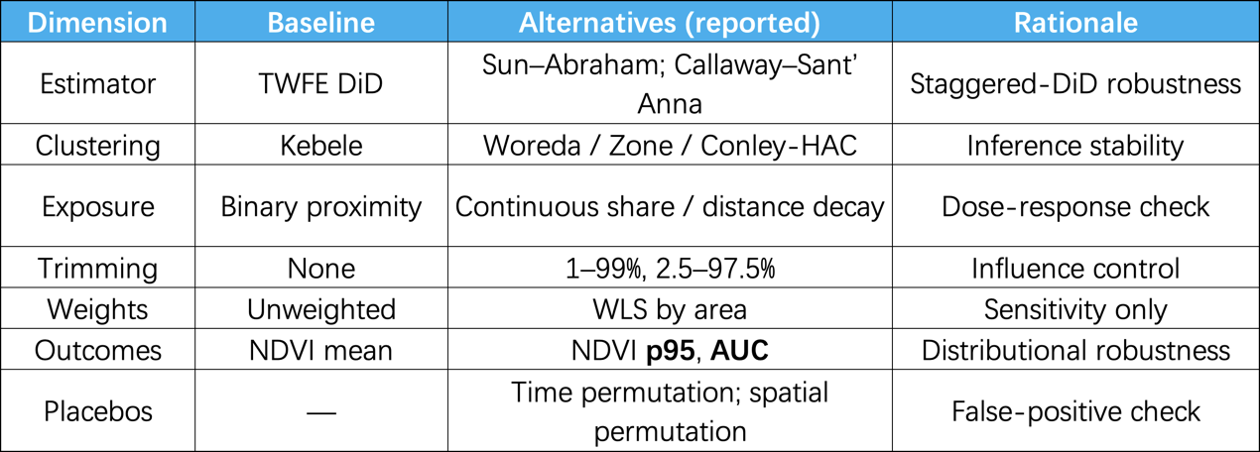

**B3. Placebo/Permutation Designs**

1. Time permutation: shuffle “intervention timing” within the pre-period; null ATT centered near zero.

2. Spatial permutation: re-assign treatment labels across kebeles while preserving adjacency; null distribution brackets the observed ATT.

3. Falsification windows: pretend treatment occurs well before any plausible irrigation effect; coefficients align with zero.

## Appendix C — Reporting, Power & Governance

**C1. Statistical Power / Minimum Detectable Effect**

With clustering and spatial correlation, very small NDVI shifts are hard to detect. Under typical ICC (0.05–0.15) and observed dispersion, the 80%-power MDE is on the order of 0.02–0.03 NDVI units (≈ 0.10–0.15 SD). Hence non-significant ATT should be read as “no evidence of large effects,” not “proven zero.”

In standardized terms, point estimates are <0.10 SD—well below a plausible policy-relevant threshold (~0.20 SD), consistent with an O&M-first prioritization.

**C2. Reproducibility & Ethics**

Workflow discipline: End-to-end scripting from GEE preprocessing → polygon aggregation → DiD estimation → tables/figures; all steps version-tagged.

Inputs/outputs: Raw EO tiles (catalogued), derived kebele panels (CSV/Parquet), and model outputs (tidy tables) are linked by deterministic filenames.

Ethics: Public satellite and administrative data only; no PII; reporting at kebele or higher; analysis aligns with institutional ethics guidance.

**C3. Policy Scorecard Prototype**

Purpose. Convert EO diagnostics into annual, auditable performance scorecards to prioritise maintenance and repair in drought years. Core fields:

• Rainfall class（CHIRPS JJAS anomaly: severe/moderate/near-normal）；

• Canopy response（event-time dip magnitude; rebound speed）；

• Outlier flags（LISA hot/cold anomalies; persistent under-performance）；

• Action triggers（e.g., “NDVI dip > τ and rebound < ρ ⇒ add to O&M queue; expansion deferred”）

In severe-drought years, kebeles with large NDVI dips and slow rebounds enter a priority repair queue; acreage expansion is deprioritised.